# Angular Advanced

## Lab Manual



Introduction to Angular 1

About this Lab Manual 4

Lab 1: Creating a New Project 7

Lab 2: Running Your Project 11

Lab 3: Styles: Using a CSS Framework 14

Lab 4: Your First Component 18

Lab 5: Creating Data Structures 22

Lab 6: Passing Data into a Component 28

Lab 7: Looping Over Data 31

Lab 8: Formatting Data for Display 33

Lab 9: More Reusable Components 35

Lab 10: Responding to an Event 39

Lab 11: Create a Form to Edit Your Data 43

Lab 12: Communicating from Child to Parent Component 47

Lab 13: Hiding and Showing Components 52

Lab 14: Preventing a Page Refresh 54

Lab 15: More Component Communication 56

Lab 16: Forms | Binding 61

Lab 17: Forms | Saving 68

Lab 18: Forms | Validation 73

Lab 19: Forms | Refactor 77

Lab 20: Services & Dependency Injection 80

Lab 21: Setup Backend REST API 84

Lab 22: HTTP GET 87

Lab 23: HTTP Error Handling 90

Lab 24: HTTP PUT 94

# About this Lab Manual

This lab manual provides a series of hands-on exercises for learning how to build web applications using Angular.

## Conventions

Each hands-on exercise in this manual will consist of a series of steps to accomplish a learning objective.

### Code Blocks

* All paths in the are relative to the **project-manage** directory. So the file below will be found at:

*angular-advanced\code\labs\working\project-manage\app.module.ts*

* Highlighted code indicates code that has changed. If the code is not highlighted it should already exist from a previous step.
* Code with a ~~Strikethrough~~ should be removed.
* **. . .** Indicates code has been omitted for formatting and clarity but you should leave these sections of code in your running application.
* Most code snippets are short and easy to type but some are longer so a file with the contents of the code to add is provided in the folder.

*angular-advanced\code\labs\snippets*

* + If a code snippets is provided for a code block the file path will appear below the code block as show below.

|  |
| --- |
| app.module.ts |
| import { NgModule } from '@angular/core'; import { AppComponent } from './app.component';  import { BrowserModule } from '@angular/platform-browser';  @NgModule({  declarations: [AppComponent], ~~imports: [BrowserModule],~~  **bootstrap: [AppComponent],**  }) |
| snippets\lab00-step00.html |

### Commands

These commands should be run in a command-prompt.

|  |
| --- |
| npm install -g @angular/cli@7.1.3  ng -v |

### Sidebars

The boxes are sidebars and should be read.

The boxes with blue borders are information and tips.

The boxes with red borders are alerts.

### Completion

At the end of each lab you will see:

### You have completed Lab …

# Lab 1: Creating a New Project

## Objectives

 Verify the Angular CLI is installed  Create a new Angular project

 Open the new project

 Review the default project structure

## Steps

### Verify the Angular CLI is installed

1. **Open** a **command prompt.**

You can be in *any* directory when you run the command because the Angular CLI is installed globally.

1. **Run** the command.

|  |
| --- |
| npm install -g @angular/cli@7.1.3  ng v |

1. **Verify** the output.

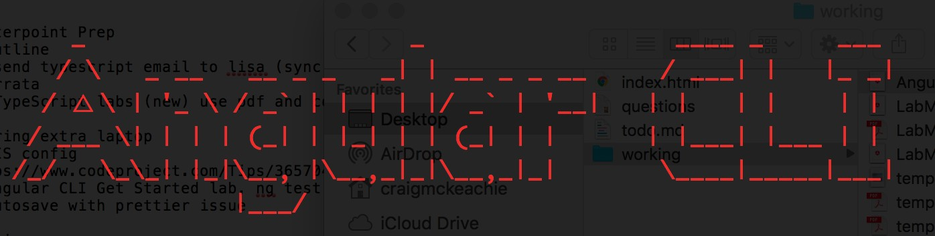

### Create a new Angular project

1. Create and change the current directory to following directory:

**angular-advanced/code/labs/working**

1. **Run** the command.

|  |
| --- |
| ng new project-manage |

1. You will receive the following prompt. **Type y** to answer yes.

|  |
| --- |
| ? Would you like to add Angular routing? (y/N) |

1. You will receive another prompt. Hit **enter** to accept the default of CSS.

|  |
| --- |
| ? Which stylesheet format would you like to use? (Use arrow keys)  ❱ CSS  SCSS [ [http://sass-lang.com](http://sass-lang.com/) ] SASS [ [http://sass-lang.com](http://sass-lang.com/) ] LESS [ [http://lesscss.org](http://lesscss.org/) ] Stylus [ [http://stylus-lang.com](http://stylus-lang.com/) ] |

1. A new Angular project will be created for you.

This could take a several minutes and requires an internet connection to install Angular and the other libraries from **npmjs.com**.

Adding Angular routings tells the Angular CLI to create a routing module where we can configure our routes.

Choosing CSS tells the CLI we want don’t want to use a preprocessor for our styles.

### Open the new project

1. Change the current directory (cd) to the directory you created in the last step.

|  |
| --- |
| cd project-manage |

1. **Open** the **project-manage** directory in the **editor**.

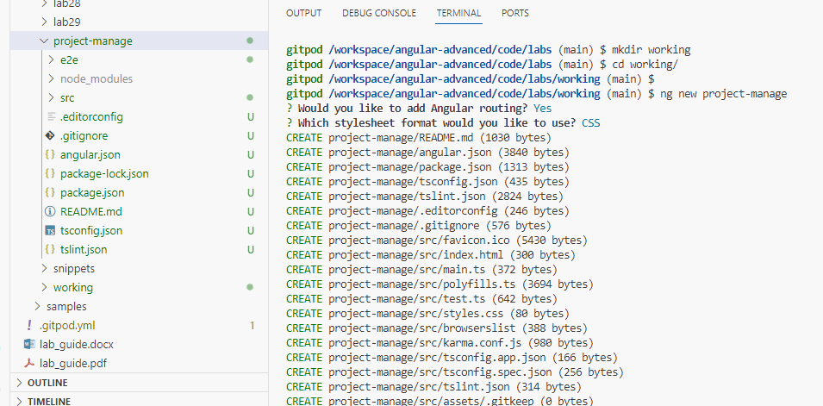

### Review the default project structure

1. Take a few minutes to go over the **default** project **structure** with your instructor. Below are some things to discuss.
   1. Open **package.json** and review the **dependencies** (JavaScript libraries) installed as well as the **scripts**.
   2. Understand each of the files involved in **bootstrapping** (starting) an Angular application.
      1. app.component.html | app.component.ts
      2. index.html
      3. app.module.ts
      4. main.ts

### You have completed Lab 1

# Lab 2: Running Your Project

## Objectives

 Run the project

 Make a change and see the app update

## Steps

### Run the project

1. If you don’t already have one open, **open** a **command prompt.** Set the directory to **project-manage**.

|  |
| --- |
| ng serve --disable-host-check |

The flag **--** **disable-host-check** will allow accessing angular app remotely.

1. **Run** the command.
2. The project will:
   * build and bundle the code
   * open a development web server
   * open your default web browser
3. The page should display an Angular logo and the text shown below.

|  |
| --- |
| Welcome to project-manage! |

If your default browser is **Internet Explorer** you will see a blank page because the **polyfills** needed to support **IE** are not included by default.

* Uncomment the following lines to get the application working in **IE**.
  + You may need to stop the web server using **Ctrl+C** and then restart it using the command from the first step of this lab.

|  |
| --- |
| src\polyfills.ts |
| *\* BROWSER POLYFILLS*  *\*/*  */** IE9, IE10 and IE11 requires all of the following polyfills. **/*  import 'core-js/es6/symbol'; import 'core-js/es6/object'; import 'core-js/es6/function'; import 'core-js/es6/parse-int'; import 'core-js/es6/parse-float'; import 'core-js/es6/number'; import 'core-js/es6/math';  import 'core-js/es6/string'; import 'core-js/es6/date'; import 'core-js/es6/array'; import 'core-js/es6/regexp'; import 'core-js/es6/map'; import 'core-js/es6/weak-map'; import 'core-js/es6/set'; |

### Make a change and see the app update

1. Open and edit the file:

|  |
| --- |
| src\app\app.component.ts |
| @Component({  selector: 'app-root',  templateUrl: './app.component.html', styleUrls: ['./app.component.css']  })  export class AppComponent { ~~title~~ ~~=~~ ~~‘project-manage’;~~ title = 'my house';  } |

1. Save your changes.
2. The browser should automatically reload and display.

|  |
| --- |
| Welcome to my house! |

### You have completed Lab 2

# Lab 3: Styles: Using a CSS Framework

## Objectives

 Install a CSS framework

 Stop and restart the build and web server  Verify styles are working in app

## Steps

### Install a CSS framework

1. **Open** a a **new** (*leave ng serve running*) **command prompt.** Set the directory to **project-manage**.
2. Run the command.

|  |
| --- |
| npm install [mini.css@3.0.0](mailto:mini.css@3.0.0) |

* + The JavaScript package manager **npm automatically adds mini.css** as a

#### dependency.

|  |  |  |
| --- | --- | --- |
| package.json | | |
| "dependencies": {  ...  "core-js": "^2.5.4",  "mini.css": "^3.0.0",  "rxjs": "^6.0.0",  "zone.js": "^0.8.26"  },  … | **Mini.css** is a **minimal**, responsive, style- agnostic **CSS framework.** Mini.css is similar to Bootstrap but lighter and **requires fewer CSS classes** so you can **focus on learning Angular** but still get a **professional** |  |
|  | **look**. |  |

1. **Include** the framework’s **stylesheet** in the Angular CLI’s configuration.

|  |
| --- |
| angular.json |
| "projects": {  "project-manage": { "root": "",  "sourceRoot": "src", "projectType": "application", "prefix": "app",  "schematics": {}, "architect": {  "build": {  "builder": "@angular-devkit/build-angular:browser", "options": {  "outputPath": "dist/project-manage", "index": "src/index.html",  "main": "src/main.ts", "polyfills": "src/polyfills.ts",  "tsConfig": "src/tsconfig.app.json", "assets": [  "src/favicon.ico", "src/assets"  ],  "styles": [  "node_modules/mini.css/dist/mini-default.min.css", "src/styles.css"  ],  "scripts": []  },  ... |

In WebStorm files with a *.min.css extension are hidden under the un-minified version of the file**.**

### Stop and restart the build and web server

1. **Focus** your cursor in the **command prompt.** and use **[Ctrl+C]** to stop the build and web server.

Windows users will be prompted if it is OK to terminate the process and should answer **[y+enter].**

1. **Run** the command.

|  |
| --- |
| ng serve --disable-host-check |

Your current directory should still be set to **project-manage**

or the above command will not work**.**

1. The application will **build** and **open** a **browser**.

### Verify styles are working in app

1. **Open** the file **app\app.component.html**.
2. **Delete** all **contents** from the file.
3. **Add** the following quote.

|  |
| --- |
| src\app\app.component.html |
| <blockquote *cite*="Benjamin Franklin">  Tell me and I forget, teach me and I may remember, involve me and I learn.  </blockquote> |
| snippets\lab03-step09.html |

1. Save your changes.
2. The browser should automatically reload and display the quote with the CSS styles shown below.

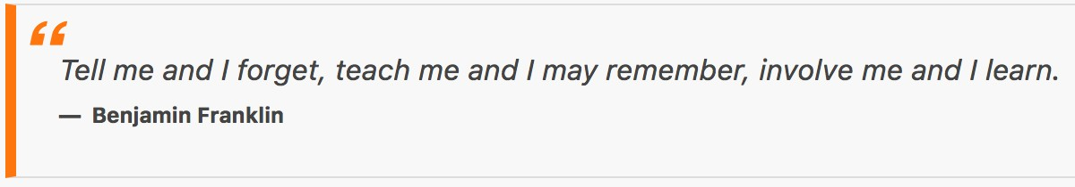

### You have completed Lab 3

# Lab 4: Your First Component

## Objectives

 Create a Feature Module  Create a Component

## Steps

### Create a Feature Module

1. If you don’t already have one open, **open** a **command prompt.** Set the directory to **project-manage**.
2. **Run** the command.

|  |
| --- |
| ng generate module projects --routing --module=app |

The **--routing** flag tells the Angular CLI to generate a module to hold our project related routes (**projects\projects- routing.module.ts**). We will use this module later in the course when we cover routing so you can safely ignore it for now.

The **--module** flag tells the Angular CLI to import the feature module for projects (**projects\projects.module.ts**) to the root module as shown in the next step.

1. **Review** the **root module** (**AppModule**) and note that the **feature module (ProjectsModule)** has been **imported** into it because of the --module flag used in the previous step.

|  |
| --- |
| src\app\app.module.ts |
| @NgModule({ declarations: [  AppComponent  ],  imports: [ BrowserModule, AppRoutingModule, ProjectsModule  ],  providers: [],  bootstrap: [AppComponent]  })  export class AppModule { } |

### Create a Component

1. **Run** the command.

|  |
| --- |
| ng g component projects/projects-container |

The Angular CLI (ng) **g** command is short for generate and by default will create files under the **src\app** directory**.** If you generate with a path prefix as we did in the example above (projects/…), the CLI will create files in that location and create the directories if they don’t already exist.

1. Because you generated the component with a **projects/** path prefix in the previous step the component will automatically be added to the declarations of the **ProjectsModule**. In order to use the component in the **AppModule** you need to list it in the **exports** of the **ProjectsModule.**

|  |
| --- |
| src\app\projects\projects.module.ts |
| ...  @NgModule({  imports: [CommonModule, ProjectsRoutingModule], declarations: [ProjectsContainerComponent],  exports: [ProjectsContainerComponent]  })  export class ProjectsModule {} |

1. Make the following changes so Angular knows where to render the component.

|  |
| --- |
| src\app\app.component.html |
| ~~<blockquote~~ *~~cite~~*~~="Benjamin Franklin">~~  ~~Tell me and I forget, teach me and I may remember, involve me and~~ ~~I learn.~~  ~~</blockquote>~~  <app-projects-container> </app-projects-container> |

1. **Save** your changes to the code.
2. Your **browser** should automatically **reload** and display the component as shown below.

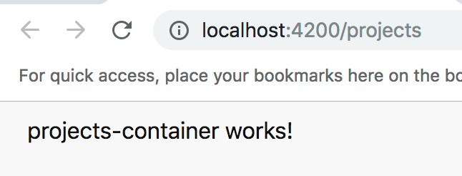

### You have completed Lab 4

# Lab 5: Creating Data Structures

## Objectives

 Create a Model or Entity Object  Add hard-coded mock data

 Display the data

## Overview

Create a model or entity object to use as a data structure in your application.

## Steps

### Create a Model or Entity Object

1. If you don’t already have one open, **open** a **command prompt.** Set the directory to **project-manage**.
2. **Run** the command.

|  |
| --- |
| ng g class projects/shared/project |

1. **Rename** the generated file from **src\app\projects\shared\project.ts** to

#### project.model.ts.

We are renaming the file above in order to follow the Angular Style Guide.

1. **Open** the file and add a constructor.

|  |
| --- |
| src\app\projects\shared\project.model.ts |
| export class Project { constructor(  public id: number,  public name: string,  public description: string,  public imageUrl: string, public contractTypeId: number, public contractSignedOn: Date,  public budget: number,  public isActive: boolean,  public editing: boolean  ) {} |
| snippets\lab05-step04.txt |

### Add hard-coded mock data

1. **Copy** the directories **snippets\Lab5-DataStructures\src** and **snippets\Lab5-DataStructures\api** *into* the **labs\working\project-manage** directory (be sure to merge the new files into the existing files).

The **snippets\Lab5-DataStructures\src** directory contains:

* a file with hard-coded mock data
* an **assets** directory which has placeholder images as well as a logo file we will use later in the course
* some pre-built components we will use in later labs

1. **Review** the hard-code mock **data**. Below is a small snippet of the data but you **should have copied the entire file** in the **previous step**.

|  |
| --- |
| src\app\projects\shared\mock-projects.ts |
| import { Project } from './project.model'; export const PROJECTS: Project[] = [  new Project( 1,  'Scarlet Weeknight',  'Fusce quis quam eget sapien sodales iaculis. Curabitur aliquet at erat sed cursus. In hendrerit.',  'assets/placeimg_500_300_arch7.jpg', 5,  new Date(2015, 1, 2),  30100,  true, false  ),  ... |
|  |

### Display the data

1. **Create** a **projects property**, strongly **type** it as an **array of projects**, and

**assign** the imported **mock** project **data**.

src\app\projects\projects-container\projects-container.component.ts

import { Component, OnInit } from '@angular/core';

import { PROJECTS } from ' ../shared/mock-projects'; import { Project } from ' ../shared/project.model';

@Component({

selector: 'app-projects-container',

templateUrl: './projects-container.component.html', styleUrls: ['./projects-container.component.css']

})

export class ProjectsContainerComponent implements OnInit { projects: Project[] = PROJECTS;

constructor() {}

ngOnInit() {}

}

1. Delete the current contents of the template. Display the array of projects data in the template.

|  |
| --- |
| src\app\projects\projects-container\projects-container.component.html |
| <h1>Projects </h1>  {{projects}} |

1. Verify the output.

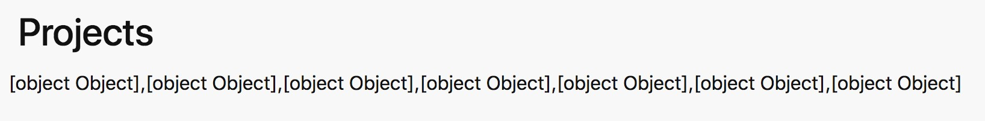

1. Format the data using a pipe to serialize the array as a string.

|  |
| --- |
| src\app\projects\projects-container\projects-container.component.html |
| <h1>Projects </h1>  {{projects | json}} |

1. Verify the output.

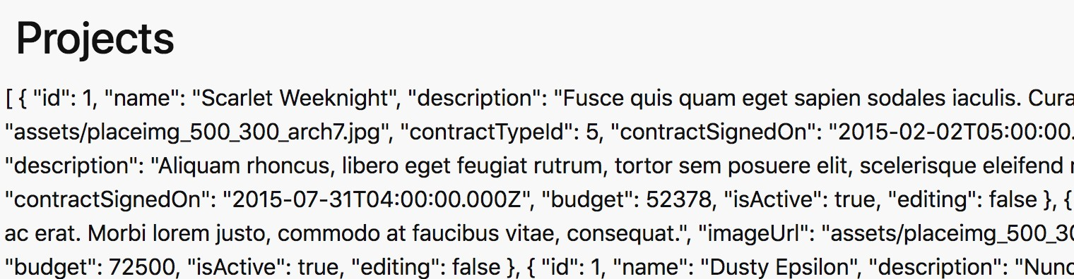

1. Wrap the formatted JSON data in a <pre> tag to preserve the whitespace.

|  |
| --- |
| src\app\projects\projects-container\projects-container.component.html |
| <h1>Projects </h1>  <pre>  {{projects | json}}  </pre> |

1. Verify the output.

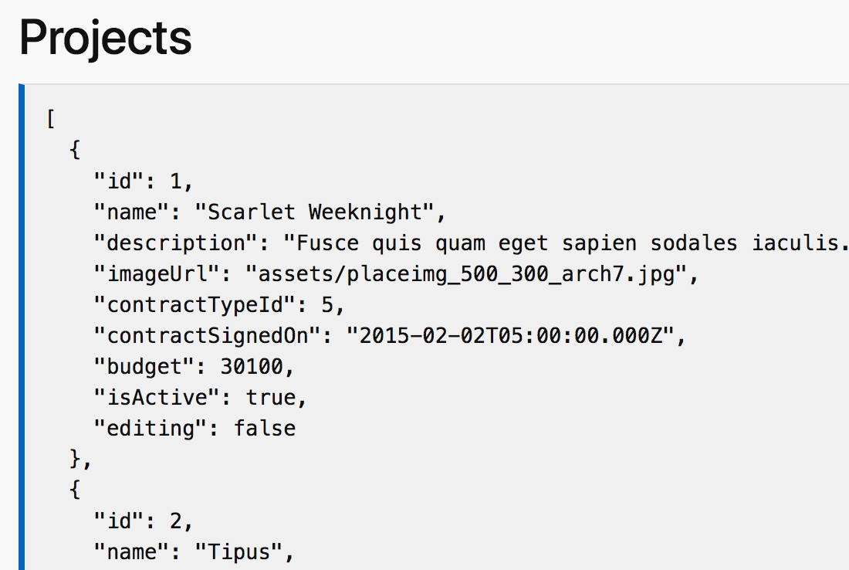

Sending output to a json pipe and wrapping it in an HTML <pre> tag is a useful debugging tip.

### You have completed Lab 5

# Lab 6: Passing Data into a Component

## Objectives

 Create a presentation component

 Pass data into the presentation component

## Steps

Use property binding and the @Input decorator to pass data into a component.

### Create a presentation component

1. If you don’t already have one open, **open** a **command prompt.** Set the directory to **project-manage**.
2. **Run** the following **command** to **generate** a **presentation** component.

|  |
| --- |
| ng g component projects/project-list |

1. **Add** an **input property** to the new component.

|  |
| --- |
| src\app\projects\project-list\project-list.component.ts |
| import { Component, OnInit, Input } from '@angular/core'; import { Project } from ' ../shared/project.model';  @Component({  selector: 'app-project-list',  templateUrl: './project-list.component.html', styleUrls: ['./project-list.component.css']  })  export class ProjectListComponent implements OnInit {  @Input()  projects: Project[] = []; constructor() {}  ngOnInit() {}  } |

1. **Remove** the **generated HTML** and **display** the **input property data** in the template.

|  |
| --- |
| src\app\projects\project-list\project-list.component.html |
| ~~<p>~~  ~~project-list works!~~  ~~</p>~~  <pre>  {{projects | json}}  </pre> |

### Pass data into the presentation component

1. **Open** the parent container component **template** file and **use** the new presentation component’s **selector** to display the data.

|  |
| --- |
| src\app\projects\projects-container\projects-container.component.html |
| <h1>Projects </h1>  ~~<pre>~~  ~~{{projects | json}}~~  ~~</pre>~~  <app-project-list *[proýects]*="projects"> </app-project-list> |

1. Verify the result is the same as the previous lab.

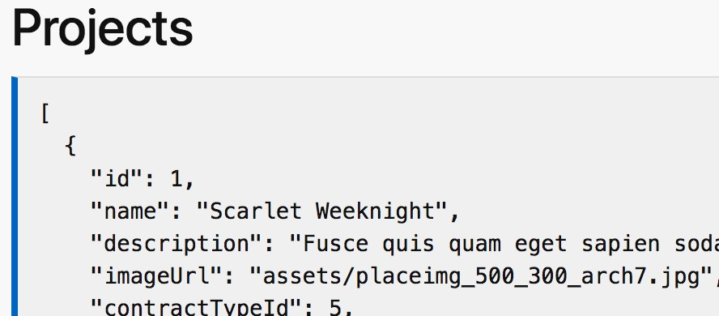

Although the results are the same we are beginning to break our UI into encapsulated, re-usable pieces.

### You have completed Lab 6

# Lab 7: Looping Over Data

## Objectives

 Loop over data

## Steps

### Loop over data

1. Open the following template and **loop** through the array of data **using** an

**ngFor** directive. Use **interpolation** and **property binding** to display the data.

|  |
| --- |
| src\app\projects\project-list\project-list.component.html |
| ~~<pre>~~  ~~{{projects | json}}~~  ~~</pre>~~  <div *class*="row">  <div *class*="cols-sm" *\*ngFor*="let project of projects">  <div *class*="card">  <img *[src]*=" project.imageUrl" *[alt]*="project.name">  <section *class*="section dark">  <h5 *class*="strong">  <strong>{{project.name}} </strong>  </h5>  <p>{{project.description}} </p>  <p>Budget : {{project.budget}} </p>  </section>  </div>  </div> |
| snippets\lab07-step01.html |

1. Verify the result.

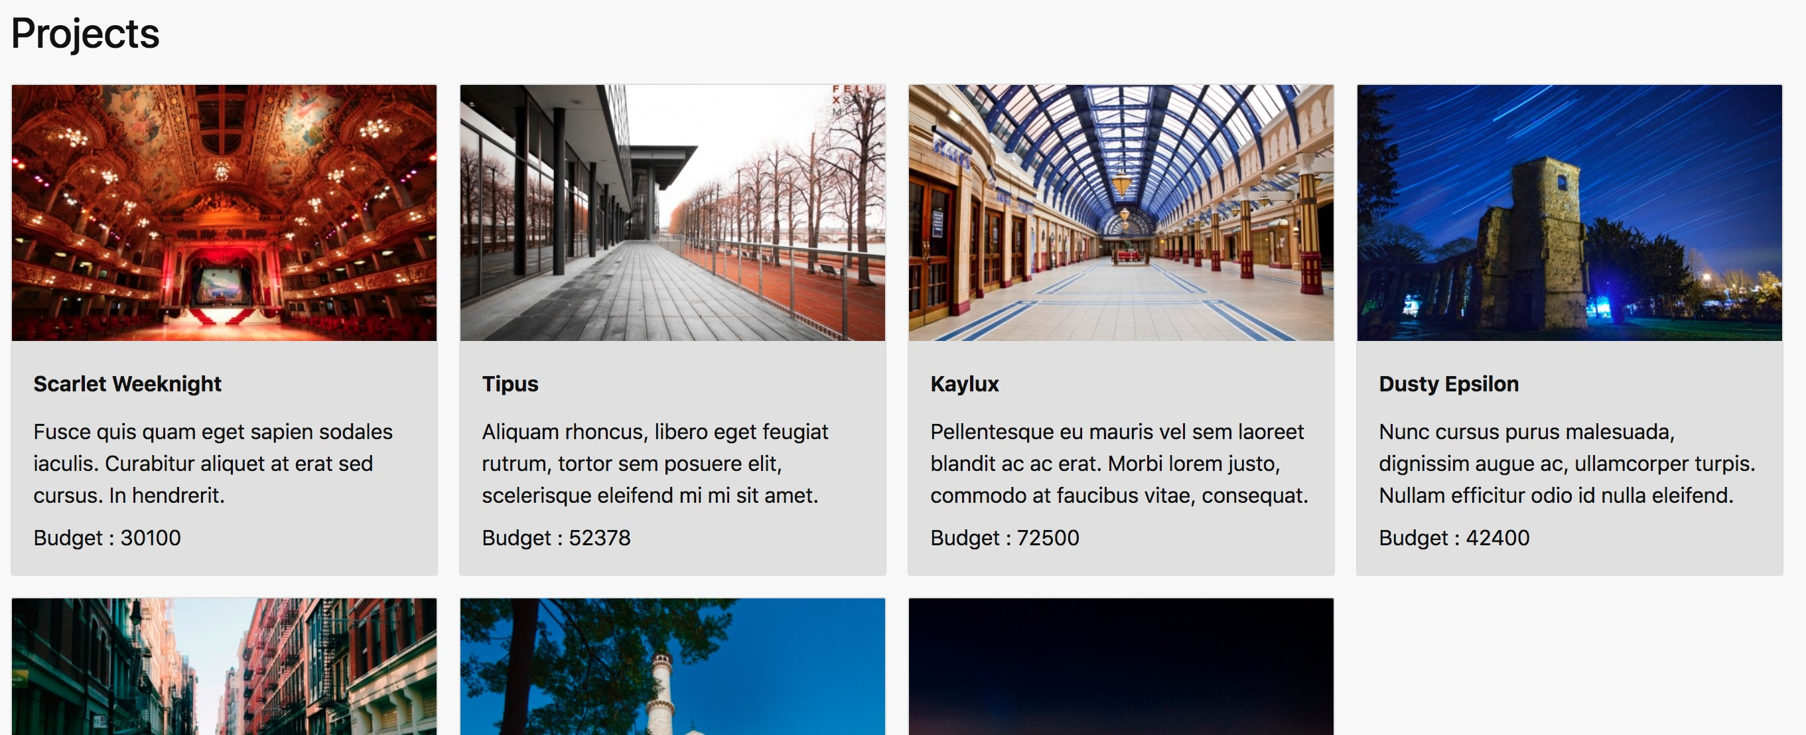

Not all boxes will be the same height at this point in the labs. We will fix this in a later lab.

### You have completed Lab 7

# Lab 8: Formatting Data for Display

## Objectives

 Format data using Angular’s built-in currency pipe

## Steps

### Format data using Angular’s built-in currency pipe

1. Open the following template and format the budget amount as currency.

|  |
| --- |
| src\app\projects\project-list\project-list.component.html |
| <div *class*="row">  <div *class*="cols-sm" *\*ngFor*="let project of projects">  <div *class*="card">  <img *[src]*=" project.imageUrl" *[alt]*="project.name">  <section *class*="section dark">  <h5 *class*="strong">  <strong>{{project.name}} </strong>  </h5>  <p>{{project.description}} </p>  ~~<p>Budget : {{project.budget}} </p>~~  <p>Budget : {{project.budget | currency : 'USD': 'symbol': '0.0-2'}} </p>  </section>  </div>  </div>  </div> |

1. Verify the result.

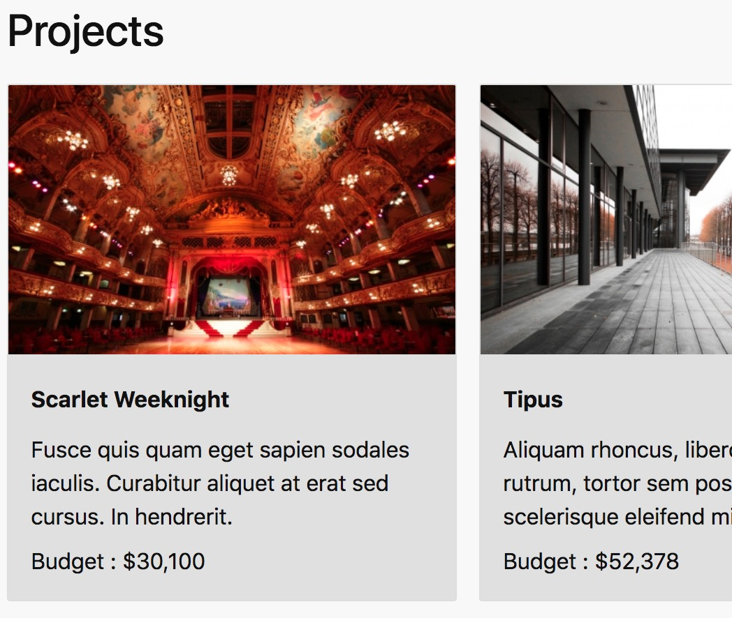

### You have completed Lab 8

# Lab 9: More Reusable Components

## Objectives

 Create a presentation component for each project  Pass a project into the presentation component

## Steps

### Create a presentation component for each project

1. If you don’t already have one open, **open** a **command prompt.** Set the directory to **project-manage**.
2. **Run** the following **command** to **generate** a **presentation** component.

|  |
| --- |
| ng g component projects/project-card |

1. **Add** an **input property** to the new component.

|  |
| --- |
| src\app\projects\project-card\project-card.component.ts |
| import { Component, OnInit, Input } from '@angular/core'; import { Project } from ' ../shared/project.model';  @Component({  selector: 'app-project-card',  templateUrl: './project-card.component.html', styleUrls: ['./project-card.component.css']  })  export class ProjectCardComponent implements OnInit {  @Input()  project: Project; constructor() {}  ngOnInit() {}  } |

1. **Cut** the HTML from the **list** template and **paste** it **into** the **card** template.

~~<p>~~

~~project-card works!~~

~~</p>~~

src\app\projects\project-card\project-card.component.html

</section>

<p>Budget : {{project.budget | currency : 'USD': 'symbol': '0.0-2'}} </p>

<p>{{project.description}} </p>

</h5>

<strong>{{project.name}} </strong>

<h5 *class*="strong">

<section *class*="section dark">

<img *[src]*=" project.imageUrl" *[alt]*="project.name">

</div>

<div *class*="card">

|  |
| --- |
| src\app\projects\project-list\project-list.component.html |
| <div *class*="row">  <div *class*="cols-sm" *\*ngFor*="let project of projects">  <div *class*="card">  <img *[src]*=" project.imageUrl" *[alt]*="project.name">  <section *class*="section dark">  <h5 *class*="strong">  <strong>{{project.name}} </strong>  </h5>  <p>{{project.description}} </p>  <p>Budget : {{project.budget | currency : 'USD': 'symbol': '0.0-2'}} </p>  </section>  </div>  </div>  </div> |

### Pass a project into the presentation component

1. Open the parent list component template file and use the new card presentation component to display the data.

|  |
| --- |
| src\app\projects\projects-list\projects-list.component.html |
| <div *class*="row">  <div *class*="cols-sm" *\*ngFor*="let project of projects">  <app-project-card *[proýect]*="project"> </app-project-card>  </div>  </div> |

1. Verify the result is the same as the previous lab.



### You have completed Lab 9

# Lab 10: Responding to an Event

## Objectives

 Use event binding to respond to a user event

## Steps

### Use event binding to respond to a user event

1. **Create** a **method** on a component **to handle** an **event**.

|  |
| --- |
| src\app\projects\project-card\project-card.component.ts |
| ...  export class ProjectCardComponent implements OnInit { @Input()  project: Project; constructor() {}  ngOnInit() {}  onEditClick(project: Project, event: Event) {  event.preventDefault();  console.log(project);  }  } |

We will **explain event.preventDefault()** in a **future lab**. We actually **don’t need** to call it **yet** but we will it in a later lab so we are **adding it now to prepare**.

1. **Add** a **button** and use event binding to **wire** it **up** to the **event handler**

method you created in the last step.

|  |
| --- |
| src\app\projects\project-card\project-card.component.html |
| <div *class*="card">  <img *[src]*=" project.imageUrl" *[alt]*="project.name">  <section *class*="section dark">  <h5 *class*="strong">  <strong>{{project.name}} </strong>  </h5>  <p>{{project.description}} </p>  <p>  Budget :  {{project.budget | currency : 'USD': 'symbol': '0.0-2'}}  </p>  <button *class*=" bordered" **(click)=“onEditClick(project, $event)"**>  <span *class*="icon-edit "> </span> Edit  </button>  </section>  </div> |
| snippets\lab10-step02.html |

1. Verify the code is working by following these steps.
   1. **Save** the file.
   2. The browser will **automatically reload** the application.
   3. In your browser, **open** the **Chrome DevTool**s by hitting **F12**

On a laptop you may need to hold down your function key while hitting F12 **[fn+F12].**

* 1. Switch the **Chrome DevTools** to the **Console** tab by clicking on it.



* 1. **Click** on the **edit button** for one of the projects.
  2. **Verify** the **project** object is **logged** to the DevTools **console**.

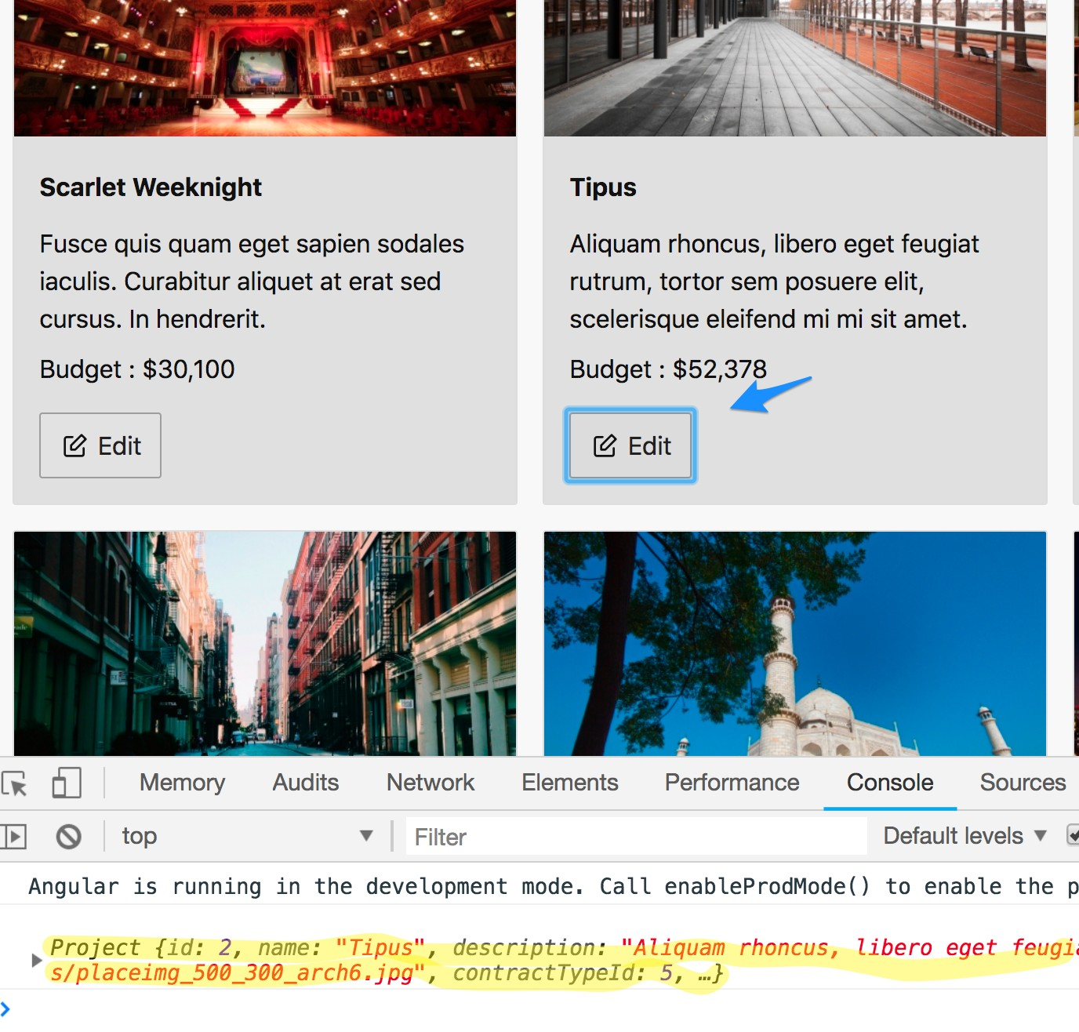

### You have completed Lab 10

# Lab 11: Create a Form to Edit Your Data

## Objectives

 Create a form component  Render a form component  Style a form component

## Steps

### Create a form component

1. If you don’t already have one open, **open** a **command prompt.** Set the directory to **project-manage**.
2. **Run** the following **command** to **generate** a **form** component.

|  |
| --- |
| ng g c projects/project-form |

The **c** in the command **ng g c** is short for component and can be used to save some typing.

1. **Add** the markup provided below to render an HTML form.

|  |
| --- |
| src\app\projects\project-form\project-form.component.html |
| <form *class*="input-group vertical">  <label *for*="name">Project Name </label>  <input *type*="text" *name*="name" *placeholder*="enter name">  <label *for*="description">Project Description </label>  <textarea *type*="text" *name*="description" *placeholder*="enter description”>  </textarea>  <label *for*="budget">Project Budget </label>  <input *type*="number" *name*="budget" *placeholder*="enter budget">  <label *for*="isActive">Active? </label>  <input *type*="checkbox" *name*="isActive">  <div *class*="input-group">  <button *class*="primary bordered medium">Save </button>  <span> </span>  <a *href*="">cancel </a>  </div>  </form> |
| snippets\lab11-step03.html |

### Render a form component

1. **Add** the form component **selector** to the list component.

|  |
| --- |
| src\app\projects\project-list\project-list.component.html |
| <div *class*="row">  <div *class*="cols-sm" *\*ngFor*="let project of projects">  <app-project-card *[proýect]*="project"> </app-project-card>  <app-project-form> </app-project-form>  </div>  </div> |

### Style a form component

1. **Add** a component style to set the minimum width of the form.

|  |
| --- |
| src\app\projects\project-form\project-form.component.css |
| form {  min-width: 300px;  }  h5 {  color: #2552b5;  } |

At this point, their is no change to the layout as the result of the min-width style being but we are adding it here because we will need it later.

1. Verify the form displays as shown below.

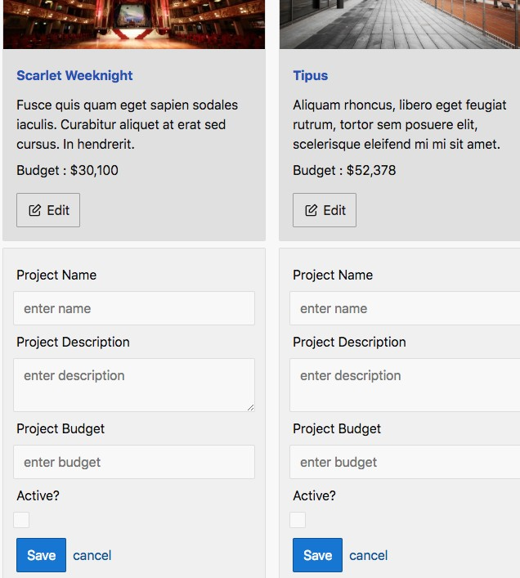

### You have completed Lab 11

# Lab 12: Communicating from Child to Parent Component

## Objectives

 Create a custom events in the child

 Listen for the custom event in the parent

## Steps

### Create a custom event in the child

1. **Create custom events**, make them available on the tag, and **emit** the **event**.

|  |
| --- |
| src\app\projects\project-card\project-card.component.ts |
| import { Component, OnInit, Input,  Output, EventEmitter } from '@angular/core';  ...  export class ProjectCardComponent implements OnInit { @Input()  project: Project;  @Output()  edit = new EventEmitter<any>();  constructor() {} ngOnInit() {}  onEditClick(project: Project, event: Event) { event.preventDefault(); ~~console.log(project);~~  this.edit.emit({ editingProject: project });  }  } |

In the last step make sure that **EventEmitter** is coming from the **correct** import **path** as shown in the code snippet.

1. Open the template to **review** how **onEditClick** is being triggered…with the click of the edit button in the card.

Note that **no code changes** are **needed** for this step, it is just a review so you can follow the flow of events in the component hierarchy.

|  |
| --- |
| src\app\projects\project-card\project-card.component.html |
| …  <button *class*=" bordered" **(click)=“onEditClick(project, $event)”**>  <span *class*="icon-edit"> </span> Edit  </button>  ... |

### Listen for the custom event in the parent

1. **Edit** the **parent component** and **create** an **event handler** that assigns the project being edited into a property and logs which project is being edited.

|  |
| --- |
| src\app\projects\project-list\project-list.component.ts |
| export class ProjectListComponent implements OnInit { @Input()  projects: Project[] = []; editingProject: Project;  onEdit(event: any) {  this.editingProject = event.editingProject;  console.log(this.editingProject);  }  constructor() {} ngOnInit() {}  } |

1. **Subscribe** your **event handler to** the **custom event**. Note that **$event** will be the **custom event object** you **emitted** in the child component.

|  |
| --- |
| src\app\projects\project-list\project-list.component.html |
| <div *class*="row">  <div *class*="cols-sm" *\*ngFor*="let project of projects">  <app-project-card *[proýect]*="project" *(edit)*="onEdit($event)">  </app-project-card>  <app-project-form> </app-project-form>  </div>  </div> |

1. Verify the code is working by following these steps.
   1. **Save** the file.
   2. The browser will **automatically reload** the application.
   3. In your browser, **open** the **Chrome DevTool**s by hitting **F12.**
   4. Switch the **Chrome DevTools** to the **Console** tab by clicking on it.



* 1. **Click** on the **edit button** for one of the projects.
  2. **Verify** the **project** object is still being **logged** to the DevTools **console**.

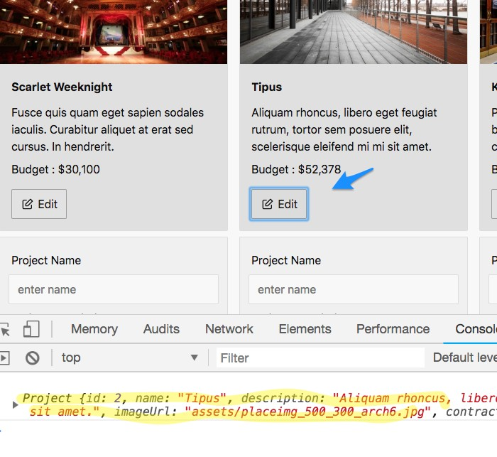

You may remember that logging was happening in a previous lab. In the previous lab, the logging was occurring in the child component. In this lab, we have removed that logging and are raising an event back up to the parent list component. This will allow the card component to be easily reused in another part of the application.

### You have completed Lab 12

# Lab 13: Hiding and Showing Components

## Objectives

 Hide and show a component using **ngIf**

## Steps

Now that current project being edited is being set into

the **editingProject** property we can use an **ngIf** directive in the template to **hide and show** the card and form when appropriate.

### Hide and show a component using ngIf

1. **Show** and **hide** the **form** when **edit** is clicked.

|  |
| --- |
| src\app\projects\project-list\project-list.component.html |
| <div *class*="row">  <div *class*="cols-sm" *\*ngFor*="let project of projects">  <app-project-card *[proýect]*="project" *(edit)*="onEdit($event)"  *\*ngIf*="project !== editingProject">  </app-project-card>  <app-project-form  \**ngIf*=“project === editingProject">  </app-project-form>  </div>  </div> |

1. Verify the form is hiding and showing by:
   1. Save your changes.
   2. Clicking on the various edit buttons on the page.

At this point, clicking save will not do anything (we’ll implement this in a later lab). Also, clicking cancel actually refreshes the entire page which we do not want to happen so we will fix that in the next lab.

### You have completed Lab 13

# Lab 14: Preventing a Page Refresh

## Objectives

 Prevent the default web browser behavior; attempting to load a page

## Overview

Click cancel and notice that the entire page reloads which should not happen in a single-page application (SPA). In this lab we will learn how to prevent this default behavior.

## Steps

### Prevent the default web browser behavior; attempting to load a page

1. Subscribe an event handler to the cancel link’s click event.

|  |
| --- |
| src\app\projects\project-form\project-form.component.html |
| <form *class*="input-group vertical">  **...**  <div *class*="input-group">  <button *class*="primary bordered medium">Save </button>  <span> </span>  <a *href*="" *(click)*="onCancelClick($event)">cancel </a>  </div>  </form> |

Since we are handling the above event with an event handler method that we don’t create until the next step your editor will underline it and give you the message **Unknown method onCancelClick**.

1. Implement the event handler method.

|  |
| --- |
| src\app\projects\project-form\project-form.component.ts |
| ...  export class ProjectFormComponent implements OnInit { constructor() {}  ngOnInit() {}  onCancelClick(event: Event) {  event.preventDefault();  }  } |

1. Verify the code is working following these steps:
   1. Click the edit button for a project.
   2. On the form that displays click the cancel link.
   3. Prior to us preventing the default browser behavior of loading a page when a link is clicked, this caused a reload of the entire page. Now clicking cancel will do nothing (but no longer reload the page).

Note that the form will not be removed because we haven’t told the parent list that the child has cancelled editing. We will do this in the next lab.

### You have completed Lab 14

# Lab 15: More Component Communication

## Objectives

 Create a custom event in the child

 Listen for the custom event in the parent

## Overview

In this lab, you the child form component will emit a custom event to the parent list component. This event will notify the list there is no longer a project being edited.

This lab is very similar to the previous component communication lab so consider it an optional lab to do only if time permits.

**You will need to follow the directions on how to skip a lab before continuing to the next lab to maintain continuity in the labs.**

## Steps

### Create a custom event in the child

1. Create a custom cancel event and emit it.

|  |
| --- |
| src\app\projects\project-form\project-form.component.ts |
| import { Component, OnInit,  Output, EventEmitter } from '@angular/core';  @Component({  selector: 'app-project-form',  templateUrl: './project-form.component.html', styleUrls: ['./project-form.component.css']  })  export class ProjectFormComponent implements OnInit {  @Output()  cancel = new EventEmitter<void>();  constructor() {} ngOnInit() {}  onCancelClick(event: Event) { event.preventDefault(); this.cancel.emit();  }  } |

### Listen for the custom event in the parent

1. **Subscribe** to the custom event in the parent list with an event handler.

|  |
| --- |
| src\app\projects\project-list\project-list.component.html |
| <div *class*="row">  <div *class*="cols-sm" *\*ngFor*="let project of projects">  <app-project-card *[proýect]*="project" *(edit)*=“onEdit($event)"  *\*ngIf*="project !== editingProject">  </app-project-card>  <app-project-form *\*ngIf*="project === editingProject"  *(cancel)*="onCancel()">  </app-project-form>  </div>  </div> |

The invocation of the onCancel() method will have a red line under it with the error “[Angular] Unknown method ‘onCancel’” if you have the Angular Language Service extension that comes as part of the Angular Essentials Extension for Visual Studio Code . It is safe to ignore this message as we will create the onCancel method in the next step but it is good to know Angular can alert you to these errors in the its templates.

1. **Implement** the **event handler** method to take the project out of edit mode.

|  |
| --- |
| src\app\projects\project-list\project-list.component.ts |
| export class ProjectListComponent implements OnInit {  ...  editingProject: Project;  ...  onCancel() {  this.editingProject = null;  }  } |

1. Verify the code is working.
   1. **Save** all your files.
   2. **Click** the **edit** button on a project and the **form should show** in place of the card.

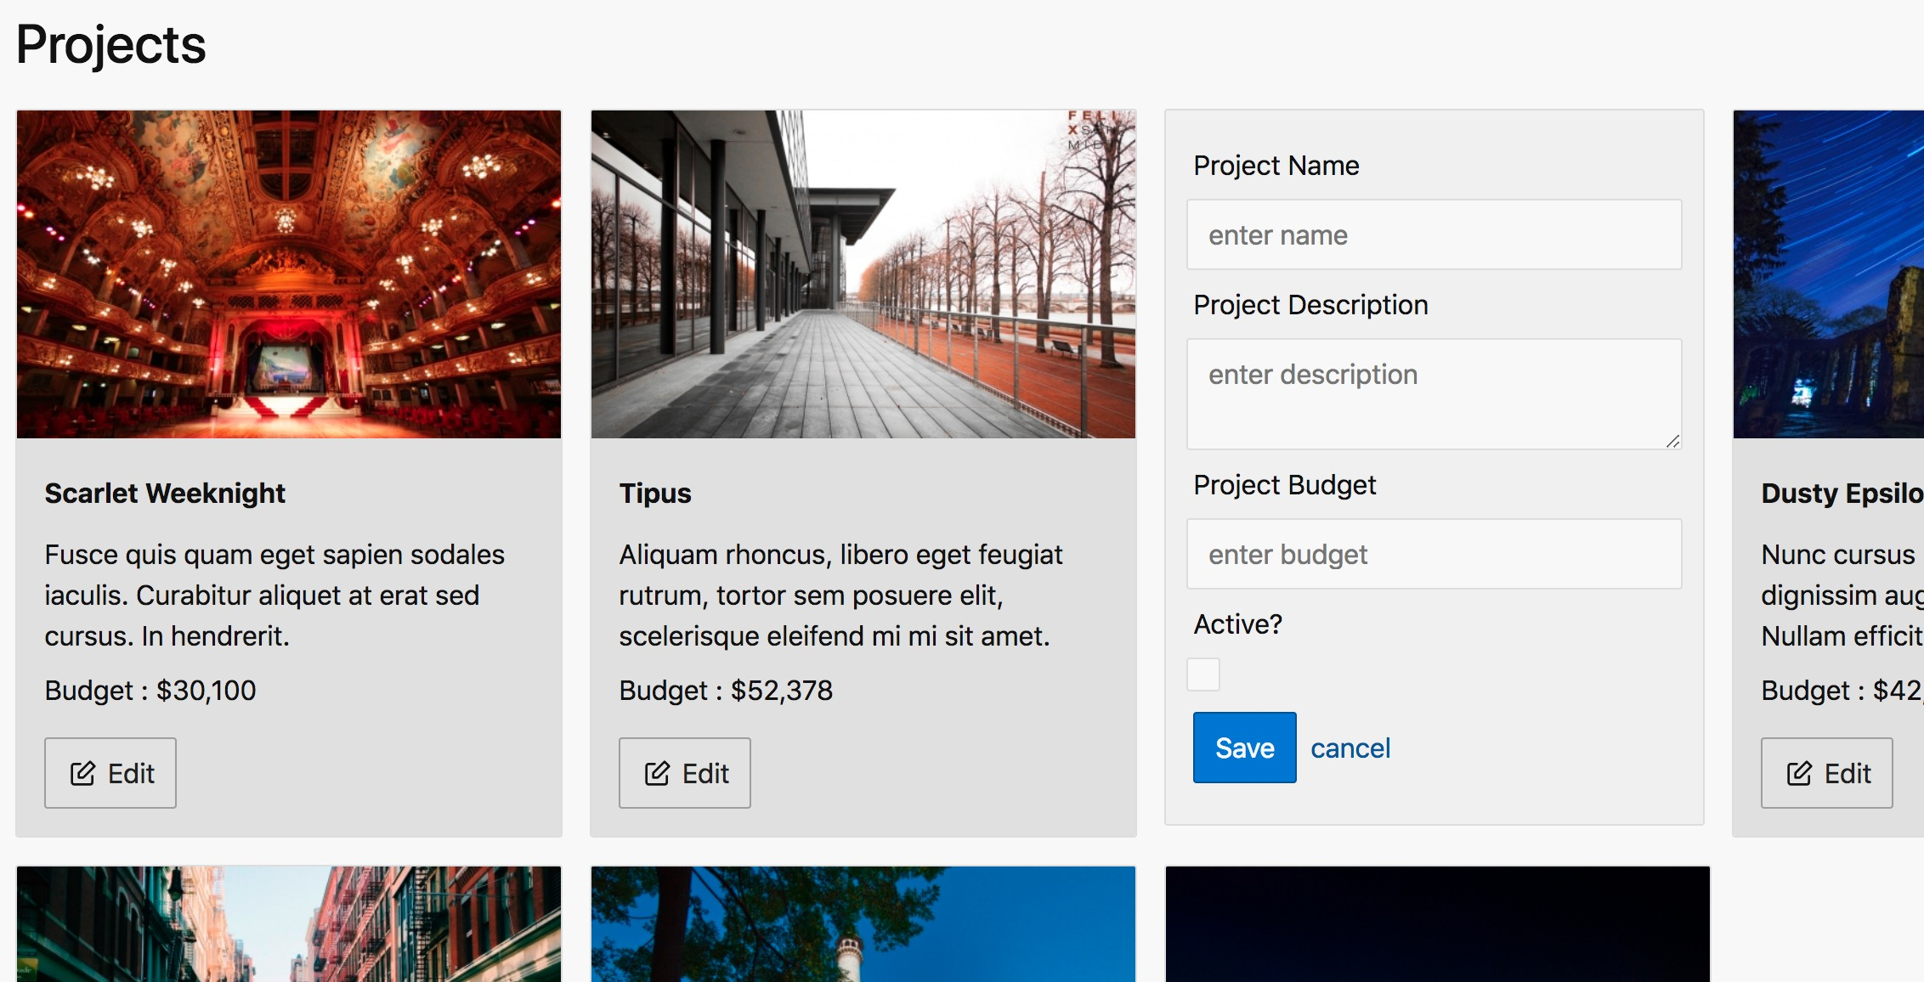

* 1. **Click** the **cancel** link and the **form should be removed** and be **replaced again by the card**.

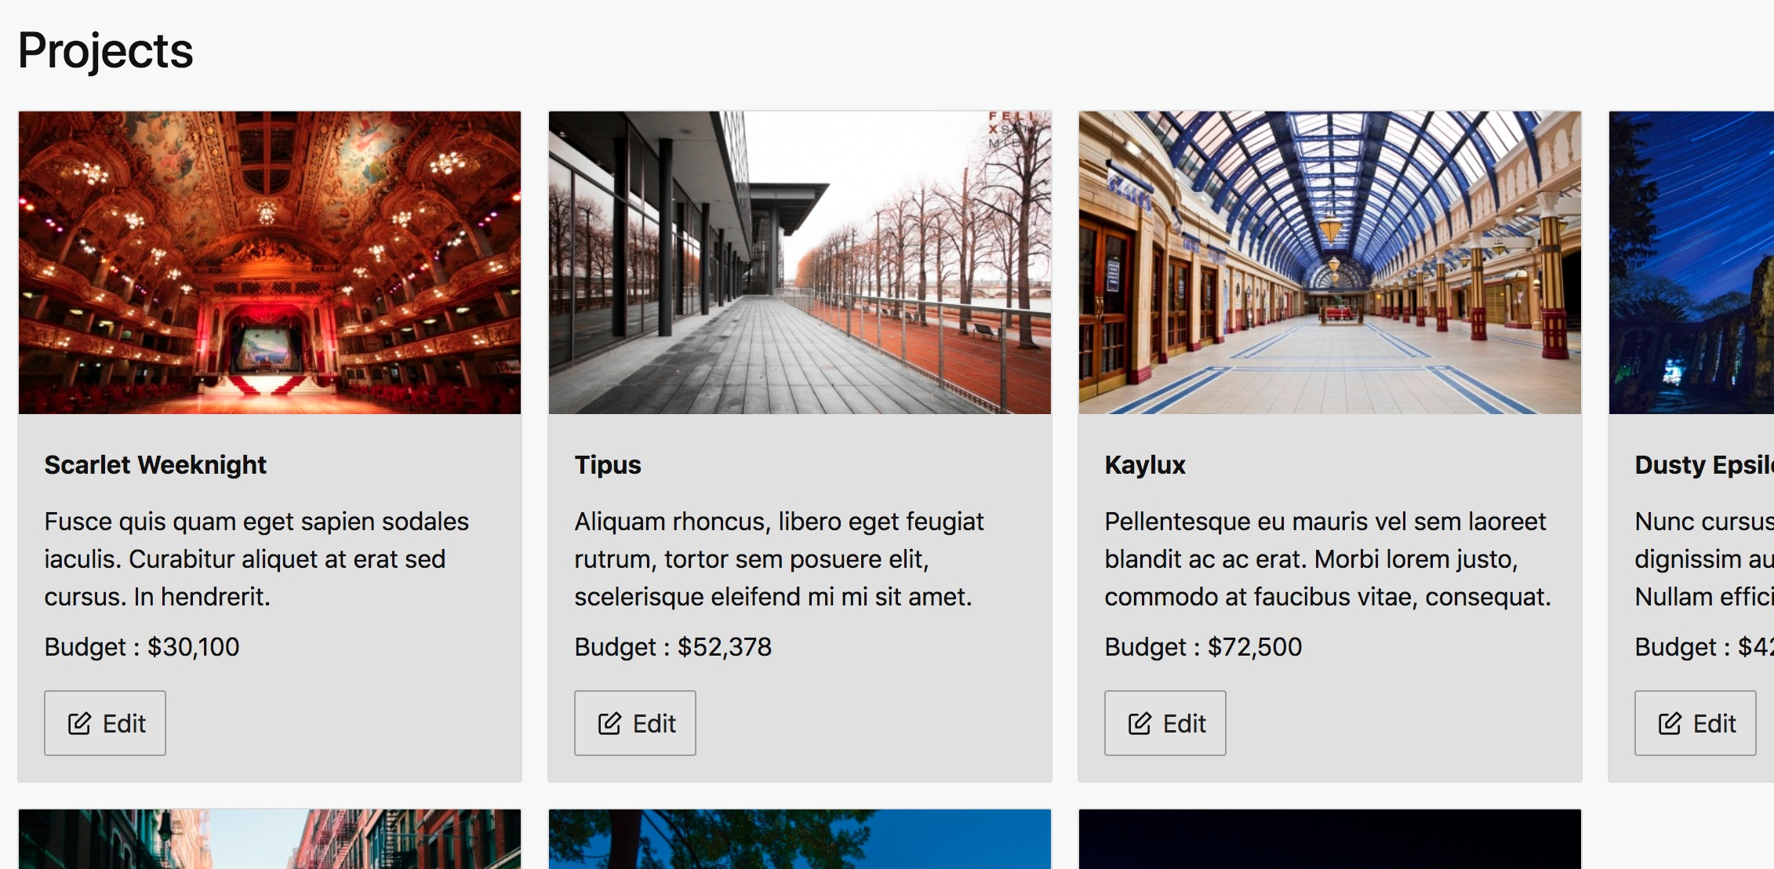

### You have completed Lab 15

# Lab 16: Forms | Binding

## Objectives

 Create a reactive binding between HTML elements and FormControl objects  Observe the reactive binding

## Steps

### Create a reactive binding between HTML elements and FormControl objects

#### Import the ReactiveFormsModule.

|  |
| --- |
| src\app\projects\projects.module.ts |
| ...  import { ReactiveFormsModule } from '@angular/forms';  @NgModule({ imports: [  CommonModule, ProjectsRoutingModule, ReactiveFormsModule  ],  declarations: [ ProjectsContainerComponent, ProjectListComponent, ProjectCardComponent, ProjectFormComponent]  })  export class ProjectsModule { } |

**Check** to make sure your **import** of the **ReactiveFormsModule** in the last step is coming from the **correct path**. Some editors automatically import this from a longer incorrect path.

1. **Create** the **FormGroup** and **FormControl** objects and **initialize** them **to** the

**values** in the project passed in to the control via the **project input property**.

|  |
| --- |
| src\app\projects\project-form\project-form.component.ts |
| import { Component, OnInit, Output, EventEmitter, Input } from '@angular/core';  import { Project } from ' ../shared/project.model';  import { FormGroup, FormControl } from '@angular/forms';  @Component({  selector: 'app-project-form',  templateUrl: './project-form.component.html', styleUrls: ['./project-form.component.css']  })  export class ProjectFormComponent implements OnInit {  @Input()  project: Project; @Output()  cancel = new EventEmitter<void>();  projectForm: FormGroup;  constructor() {} ngOnInit() {  this.projectForm = new FormGroup({  name: new FormControl(this.project.name),  description: new FormControl(this.project.description),  budget: new FormControl(this.project.budget),  isActive: new FormControl(this.project.isActive)  });  }  ... |
| snippets\lab16-step02.txt |

1. **Update** the list control **template** to **set** the **project** (created in the last step) into the input property **using property binding synta**x.

|  |
| --- |
| src\app\projects\project-list\project-list.component.html |
| <div *class*="row">  <div *class*="cols-sm" *\*ngFor*="let project of projects">  <app-project-card *[proýect]*="project" *(edit)*="onEdit($event)"  *\*ngIf*="project !== editingProject">  </app-project-card>  <app-project-form *[proýect]*="project"  *\*ngIf*="project === editingProject" *(cancel)*="onCancel()">  </app-project-form>  </div>  </div> |

1. **Annotate** your form **with** Angular's **form directives** and **output** the **values**.

|  |
| --- |
| src\app\projects\project-form\project-form.component.html |
| <form *[formGroup]*="projectForm" *class*="input-group vertical">  <label *for*="name">Project Name </label>  <input *type*="text" *name*="name" *placeholder*="enter name"  *formControlName*="name">  <label *for*="description">Project Description </label>  <textarea *type*="text" *name*="description" *placeholder*="enter description" *formControlName*="description"> </textarea>  <label *for*="budget">Project Budget </label>  <input *type*="number" *name*="budget" *placeholder*="enter budget"  *formControlName*="budget">  <label *for*="isActive">Active? </label>  <input *type*="checkbox" *name*="isActive" *formControlName*="isActive">  <div *class*="input-group">  <button *class*="primary bordered medium">Save </button>  <span> </span>  <a *href*="" *(click)*="onCancelClick($event)">cancel </a>  </div>  <pre *style*="width: 300px">  {{projectForm.value | json}}  </pre>  </form> |

### Observe the reactive binding

Sending the form values to a json pipe in the previous step allows us to see the two-way binding going on between the HTML elements and the FormControl objects in the next step.

1. **Observe** the **binding** created by following these steps:
   1. **Save** the changes to your code and your browser will reload.
   2. **Click** the **edit** button for a project.
   3. **Change** any of the **form elements** and **see** the **changes** reflected in the FormGroup object’s **values** shown below the form.

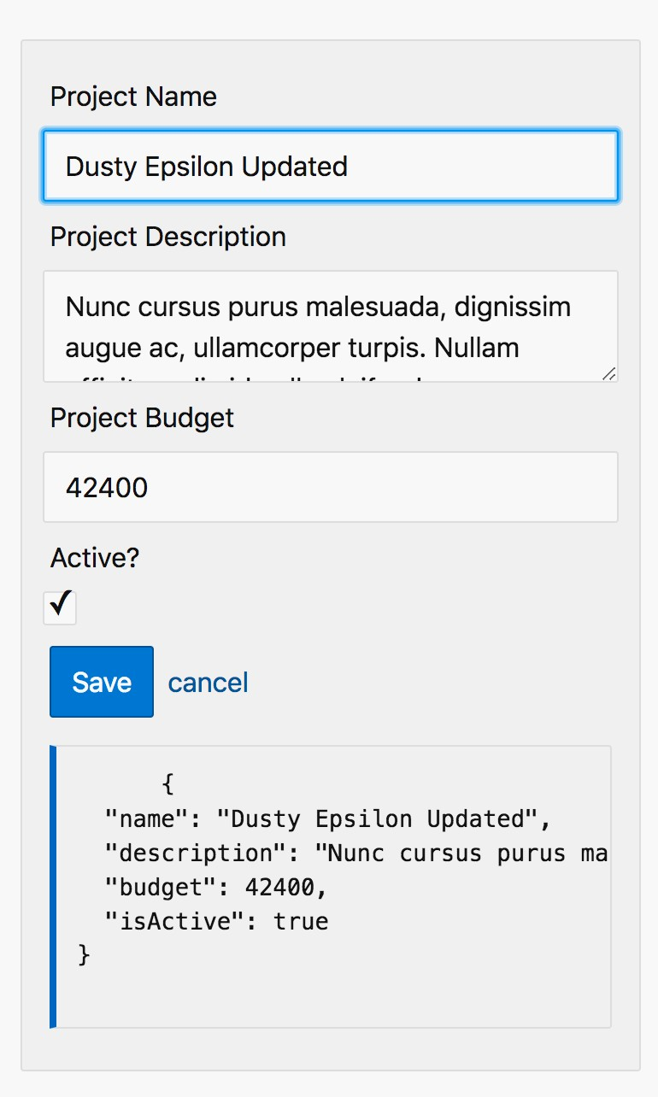

At this point clicking the **Save** button will **not** be **working yet**. You will only be able to see your changes in the values shown below the form.

1. **Remove** the **pre** tag that displays the FormGroup’s values before continuing.

|  |
| --- |
| src\app\projects\projects-form\project-form.component.html |
| <form *[formGroup]*="projectForm" *class*="input-group vertical”>  ...  ~~<pre~~ *~~style~~*~~="width: 300px">~~  ~~{{projectForm.value | json}}~~  </pre>  </form> |

### You have completed Lab 16

# Lab 17: Forms | Saving

## Objectives

 Save the form values

## Steps

### Save the form values

There are many steps involved in communicating the updated form values from the form component up through the list component before they finally reach the container (smart) component. The architecture pattern of having one container/ smart component that does the heavy lifting of talking to a backend REST API and having other presentation (dumb) components that just take inputs and emit events is common in JavaScript applications that use a component based architecture. This pattern can be found in Angular, React, and Vue.js applications.

The main advantage you will experience from architecting your applications this way is that your presentation components will be easier to reuse in other parts of your application. Consider that our form component could be used in an update scenario as we have here but also easily reused to add a new item.

The steps begin on the next page.

1. **Emit** a custom event in the form component.

|  |
| --- |
| src\app\projects\project-form\project-form.component.ts |
| export class ProjectFormComponent implements OnInit { @Input()  project: Project; Be sure you add an  @Output() @Output decorator  save = new EventEmitter<any>(); to **both** the save and  @Output()  cancel = new EventEmitter<void>(); cancel properties.  ...  projectForm: FormGroup;  ...  onSubmit() {  if (this.projectForm.invalid) {  return;  }  const updatedProject = Object.assign(  {},  this.project,  this.projectForm.value  );  this.save.emit({ project: updatedProject }); |
| snippets\lab17-step01.txt |

|  |
| --- |
| src\app\projects\project-form\project-form.component.html |
| <form *[formGroup]*="projectForm" *class*="input-group vertical”  (submit)="onSubmit()">  **...**  </form> |

1. **Subscribe** to the custom event in the list component and emit a new custom event.

|  |
| --- |
| src\app\projects\project-list\project-list.component.ts |
| import { Component, OnInit, Input,  Output, EventEmitter } from '@angular/core';  ...  export class ProjectListComponent implements OnInit {  ...  @Output()  saveListItem = new EventEmitter<any>();  ...  onSave(event: any) {  this.editingProject = null;  this.saveListItem.emit({ item: event.project });  }  ...  } |

|  |
| --- |
| src\app\projects\project-list\project-list.component.html |
| ...  <app-project-form *[proýect]*="project"  *\*ngIf*="project === editingProject" *(cancel)*="onCancel()" *(save)*="onSave($event)">  </app-project-form>  ... |

1. **Subscribe** to that custom event in the container (smart) component and update the item in the project array.

|  |
| --- |
| src\app\projects\projects-container\projects-container.component.ts |
| ...  export class ProjectsContainerComponent implements OnInit { projects: Project[] = PROJECTS;  constructor() {} ngOnInit() {}  onSaveListItem(event: any) {  const project: Project = event.item; const index = this.projects.findIndex(  element => element.id === project.id  );  this.projects[index] = project;  } |
| snippets\lab17-step03.txt |

|  |
| --- |
| src\app\projects\projects-container\projects-container.component.html |
| <h1>Projects </h1>  <app-project-list *[proýects]*="projects" *(saveListItem)*="onSaveListItem($event)">  </app-project-list> |

1. Verify the code is working by following these steps.
   1. Click the edit button for a project.

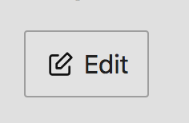

* 1. Change the project name in the form.

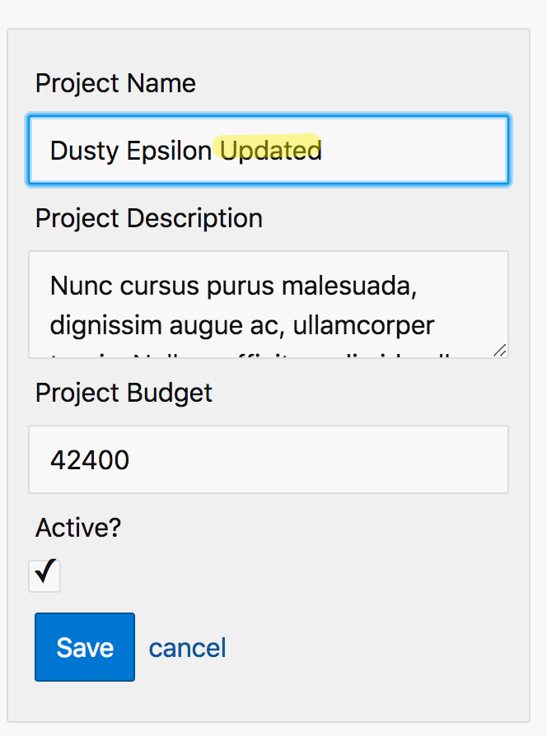

* 1. Click save on the form.
  2. Verify the card shows the updated data.

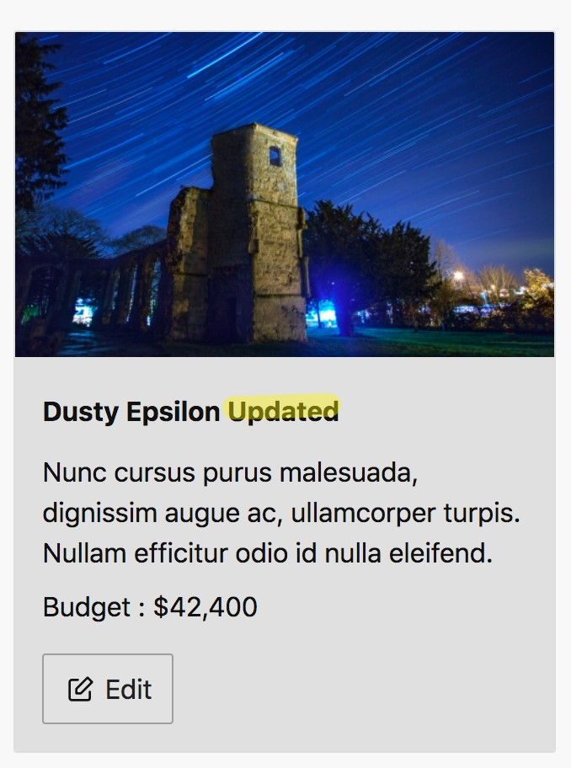

Note that if you refresh your browser page your changes will not persist because the updates are only happening in the browsers memory. We will get this working in a future lab when we communicate to our backend web API.

### You have completed Lab 17

# Lab 18: Forms | Validation

## Objectives

 Add form validation

## Steps

### Add form validation

1. Add validation functions to your controls.

|  |
| --- |
| src\app\projects\project-form\project-form.component.ts |
| import { FormGroup, FormControl,  Validators } from '@angular/forms';  ...  export class ProjectFormComponent implements OnInit {  ...  ngOnInit() {  this.projectForm = new FormGroup({  name: new FormControl(this.project.name, [  Validators.required,  Validators.minLength(3)  ]),  description: new FormControl(this.project.description), budget: new FormControl(this.project.budget),  isActive: new FormControl(this.project.isActive)  });  }  ...  } |

1. Display the validation messages.

<form *[formGroup]*="projectForm" *class*="input-group vertical" *(submit)*="onSubmit()">

<label *for*="name">Project Name </label>

<input *type*="text" *name*="name" *placeholder*="enter name" *formControlName*="name">

**...**

src\app\projects\project-form\project-form.component.html

</div>

<div *\*ngIf*="projectForm.get('name') ?.hasError('minlength')" *class*="card error">

</div>

<div *\*ngIf*="projectForm.get('name') ?.hasError('required')" *class*="card error">

<p>Name must be at least 3 characters long. </p>

<p>Name is required. </p>

1. Style the validation messages.

|  |
| --- |
| src\styles.css |
| */* You can add global styles to this file, and also import other style files */*  input*.ng-invalid* {  border-color: var( --input-invalid-color); box-shadow: none;  }  label*.invalid* {  color: var( --input-invalid-color);  } |
| snippets\lab18-step03.css |

1. Dynamically add the invalid CSS class to the label so it is styled as well.

|  |
| --- |
| src\app\projects\project-form\project-form.component.ts |
| <form *[formGroup]*="projectForm" *class*="input-group vertical" *(submit)*="onSubmit()">  <label *for*="name" *[class.invalid]*="projectForm.get('name').invalid"> Project Name  </label>  <input *type*="text" *name*="name" *placeholder*="enter name" *formControlName*="name">  **...** |

1. Verify the code is working by following these steps:
   1. Click the edit button on any project
   2. Delete the contents of the project name textbox.
   3. The error message should display immediately and the control label will turn red.
   4. 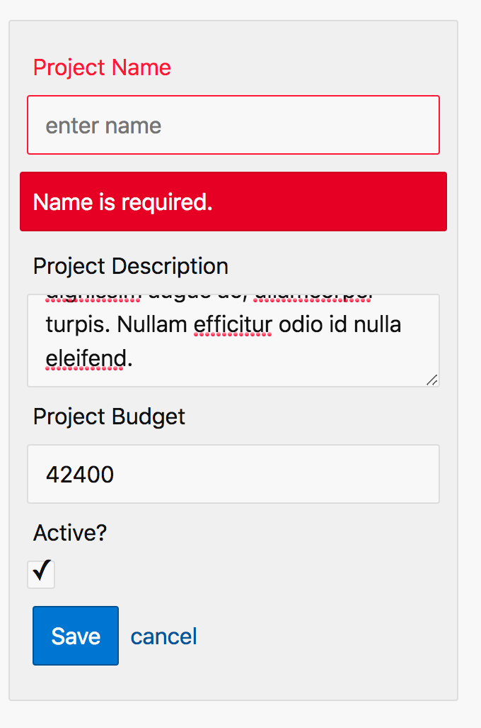Cause the input field to lose focus by tabbing out of it or clicking on another input field.
   5. You should see a red border around the invalid control.

If you don’t lose focus on the input field you will not see the red border because the styles applied on focus are overriding the invalid style. This is reasonable behavior but the user experience does not seem ideal. The real problem is that the validation message and red label are showing too early while the user is still working. We will fix this in the next lab.

### You have completed Lab 17

# Lab 19: Forms | Refactor

## Objectives

 Refactor the forms validation code so it is reusable

## Steps

### Refactor the forms validation code so it is reusable

In an earlier lab, we copied some files into the Angular CLI project we created. One of the directories we copied contained a reusable component to display validation errors. You can find the code in your project at the following path: **src\app\shared\validation-errors**

We will use this component to refactor or forms validation code so it more reusable.

#### Import the ValidationErrorsComponent into the ProjectsModule.

|  |
| --- |
| src\app\projects\projects-module.component.ts |
| import { ValidationErrorsComponent } from ' ../shared/validation- errors/validation-errors.component';  @NgModule({ declarations: [  … ValidationErrorsComponent  ]  })  export class ProjectsModule {} |

1. Replace the current error messages with the new control. Remove the [class.invalid] property binding from the control’s label as well.

|  |
| --- |
| src\app\projects\project-form\project-form.component.html |
| <form *[formGroup]*="projectForm" *class*="input-group vertical" *(submit)*="onSubmit()">  <label *for*="name" *~~[class.invalid]~~*~~="projectForm.get('name') ?.invalid"~~> Project Name  </label>  <input *type*="text" *name*="name" *placeholder*="enter name" *formControlName*="name">  <app-validation-errors *[control]*=“projectForm.get('name')">  </app-validation-errors>  ~~<div~~ *~~*ngIf~~*~~="projectForm.get('name') ?.hasError('required')"~~ *~~class~~*~~="card error">~~  <p>Name is required. </p>  ~~</div>~~  ~~<div~~ *~~*ngIf~~*~~="projectForm.get('name') ?.hasError('minlength')"~~ *~~class~~*~~="card error">~~  <p>Name must be at least 3 characters long. </p>  ~~</div>~~  … |

1. Verify the code is working by following these steps:
   1. Click the edit button on any project
   2. Delete the contents of the project name text box.
   3. Cause the input field to lose focus by tabbing out of it or clicking on another input field.
   4. You should see the validation message as well as a red border around the invalid control.

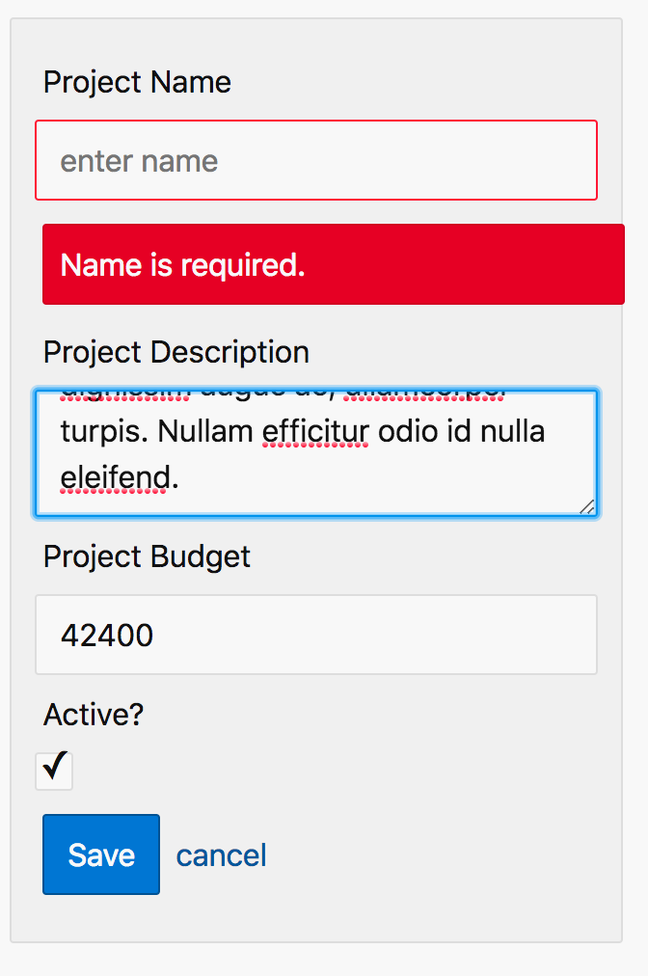

### You have completed Lab 19

# Lab 20: Services & Dependency Injection

## Objectives

 Create your first service

 Inject the service into a component

## Steps

### Create your first service

1. If you don’t already have one open, **open** a **command prompt.** Set the directory to **project-manage**.
2. **Run** the following **command** to **generate** a **form** component.

|  |
| --- |
| ng g service projects/shared/project |

1. **Implement** a **method** to **list** all products.

import { Injectable } from '@angular/core';

@Injectable({ providedIn: 'root'

})

export class ProjectService {

constructor() { }

list(): Observable<Project[]> {

return of(PROJECTS);

}

}

src\app\projects\shared\project.service.ts

import { Observable, of } from 'rxjs'; import { Project } from './project.model'; import { PROJECTS } from './mock-projects';

The **of** function is part of the **rxjs** library and is a **creation operator** meaning it creates an **Observable**. In this case, the Observable will return the projects.

### Inject the service into a component

1. **Inject** the **service** into the container component and **use** it to **access** the project **data**. *Be sure to* ***remove*** *the assignment of the projects property to the* ***hard-coded array*** *of mock data (****PROJECTS****)*.

|  |
| --- |
| src\app\projects-container\projects-container.component.ts |
| ...  import { ProjectService } from ' ../shared/project.service';  ...  export class ProjectsContainerComponent implements OnInit { projects: Project[] = PROJECTS;  constructor(private projectService: ProjectService) {}  ngOnInit() {  this.projectService.list().subscribe(data => {  this.projects = data;  });  }  ...  } |

1. **Verify** the code is **working**.
   1. **Save** the files and the **browser** will **automatically reload**.
   2. As in previous labs, the **list** of **projects** will appear.

Check your command prompt or terminal where **ng serve --disable-host-check** is running to ensure you don’t have any compiler errors. If you receive the error: **Property 'list' does not exist on type ‘ProjectService’** you will need to stop ng serve **Ctrl+C** and restart the command **ng serve --disable-host-check** to resolve the issue.

Although there are no visible changes to the application you have moved your data access to a reusable service so it can be shared with and used by other components.

### You have completed Lab 20

# Lab 21: Setup Backend REST API

## Objectives

 Install the backend REST API server

 Create a custom npm script to run the REST API server  Start the REST API server

## Steps

### Install the backend REST API server

1. **Open** another **command prompt.** Set the directory to **project-manage**.

You should already have another command prompt or terminal open in the project-manage directory that is running your Angular application using a development web server. *Leave this server running* and start another command prompt or terminal to run the web server to serve your backend REST API.

1. Run the command.

|  |
| --- |
| npm install [json-](mailto:json-server@0.14.0)[server@0.14.0](mailto:server@0.14.0) |

### Create a custom npm script to run the REST API server

1. **Add** a **script** to **start** the **backend** REST API.

|  |
| --- |
| package.json |
| {  "name": "project-manage", "version": "0.0.0", "scripts": {  "ng": "ng",  "start": "ng serve",  "build": "ng build",  "test": "ng test",  "lint": "ng lint",  "e2e": "ng e2e",  "api": "json-server ./api/db.json"  },  ...  } |

### Start the REST API server

1. In a **command prompt** with the current directory set to **project-manage**.
2. **Run** the npm **script**.

|  |
| --- |
| npm run api |

The **run** command is short for **run-script.** Running the backend json-server through an npm script ensures that we are using the local version of the server we just installed and not a previously installed global version.

1. The server should start and output similar to the following should display.

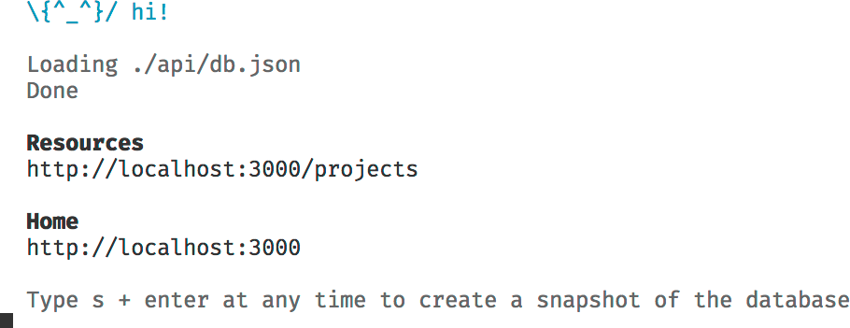

1. In your Chrome browser open: http://localhost:3000/projects
2. You should see JSON data being returned.

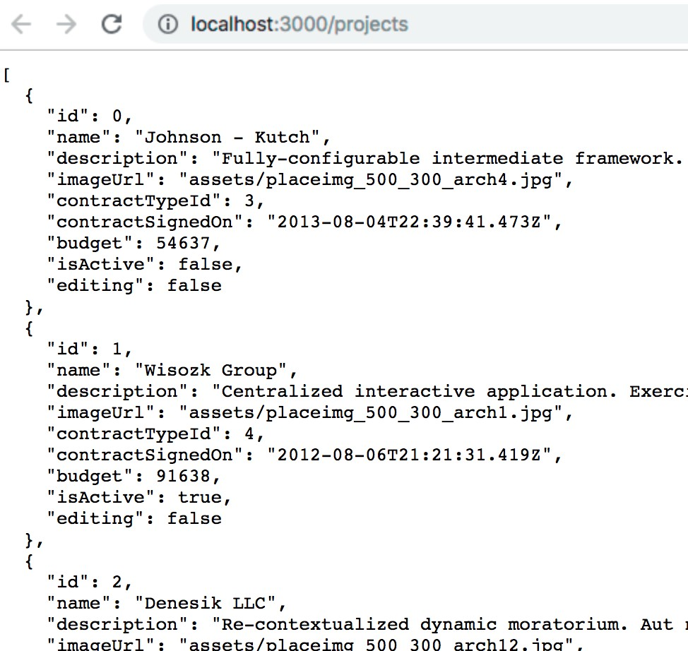

### You have completed Lab 21

# Lab 22: HTTP GET

## Objectives

 Load the data from the REST API

## Steps

### Load the data from the REST API

#### Import the HttpClientModule.

|  |
| --- |
| src\app\app.module.ts |
| import { HttpClientModule } from '@angular/common/http';  @NgModule({  declarations: [AppComponent], imports: [  BrowserModule, AppRoutingModule, ProjectsModule, HttpClientModule  ],  providers: [],  bootstrap: [AppComponent]  })  export class AppModule {} |

Sometimes your editor won’t automatically bring in an import. If this happens, try typing import and use the suggested **import statement** code snippet.

1. **Add** the **backendUrl** to **both** environment files.

|  |
| --- |
| src\environments\environment.ts | environment.prod.ts |
| *// This file can be replaced during build by using the `fileReplacements` array.*  *// `ng build ---prod` replaces `environment.ts` with `environment.prod.ts`.*  *// The list of file replacements can be found in `angular.ýson`.*  export const environment = { production: false,  backendUrl: 'http: //localhost:3000'  };  … |

1. **Inject** the **HttpService** and make a **GET request**.

|  |
| --- |
| src\app\projects\shared\project.service.ts |
| import { HttpClient } from '@angular/common/http';  import { environment } from ' ../ ../ ../environments/environment';  @Injectable({ providedIn: 'root'  })  export class ProjectService {  private projectsUrl = environment.backendUrl + '/projects/'; constructor(private http: HttpClient) {}  list(): Observable<Project[]> { ~~return~~ ~~of(PROJECTS);~~  return this.http.get<Project[]>(this.projectsUrl);  }  } |

1. **Verify** the code is **working**.
   1. **Save** the files and the **browser** will **automatically reload**.
   2. As in previous labs, the **list** of **projects** will appear.
   3. **Open** Chrome **DevTools (F12)**
   4. Click the **Network** tab> Set the **XHR** filter> Click the **projects/** request.

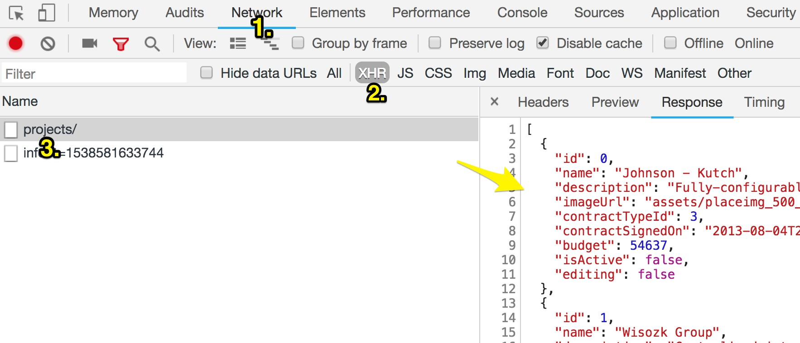

The data is now being loaded from the backend REST API. **XHR** stands for **XML HTTP Request** (the formal name for AJAX).

### You have completed Lab 22

# Lab 23: HTTP Error Handling

## Objectives

 Handle a HTTP error and translate it to a user-friendly error  Display the user friendly error

## Steps

### Handle a HTTP error and translate it to a user-friendly error

1. Update the data service to handle HTTP errors**.**

|  |
| --- |
| src\app\projects\shared\project.service.ts |
| import { Observable, of, throwError } from 'rxjs'; import { catchError } from 'rxjs/operators';  import { HttpClient, HttpErrorResponse } from '@angular/common/http';  ...  export class ProjectService {  private projectsUrl = environment.backendUrl + '/projects/'; constructor(private http: HttpClient) {}  list(): Observable<Project[]> {  return this.http.get<Project[]>(this.projectsUrl).pipe(  catchError((error: HttpErrorResponse) => {  console.log(error);  return throwError('An error occurred loading the projects.');  })  );  }  } |

### Display the user friendly error

1. **Add** an error method handler in the component.

...

export class ProjectsContainerComponent implements OnInit { projects: Project[];

errorMessage: string;

constructor(private projectService: ProjectService) {} ngOnInit() {

this.projectService.list().subscribe( data => {

this.projects = data;

},

error => {

this.errorMessage = error;

}

);

}

...

}

src\app\projects\projects-container\projects-container.component.ts

1. **Display** the **error** in the template.

|  |
| --- |
| src\app\projects\projects-container\projects-container.component.html |
| <h1>Projects </h1>  <div *class*="row">  <div *\*ngIf*="errorMessage" *class*="card large error">  <section>  <p>  <span *class*="icon-alert inverse "> </span> {{errorMessage}}  </p>  </section>  </div>  </div>  <app-project-list  *[proýects]*="projects" *(saveListItem)*="onSaveListItem($event)">  </app-project-list> |

1. **Change** the **URL** so the API endpoint cannot be reached.

|  |
| --- |
| src\app\projects\shared\project.service.ts |
| …  export class ProjectService {  private projectsUrl = environment.backendUrl + '/projects/wrong';  ...  } |

1. In your browser, you should **see** the **error message** displayed.

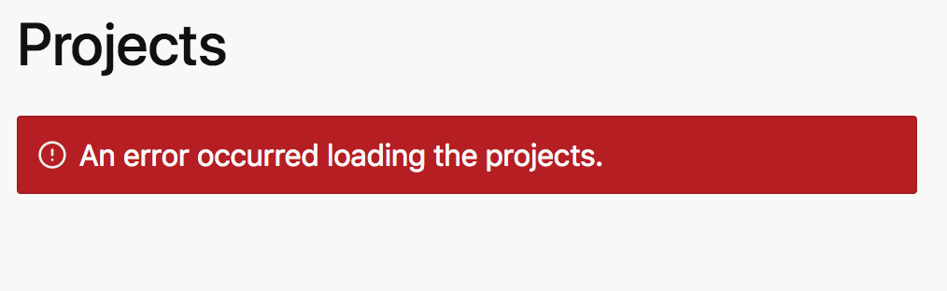

1. **Fix** the **URL** to the backend API before continuing to the next lab.

|  |
| --- |
| src\app\projects\shared\project.service.ts |
| …  export class ProjectService {  private projectsUrl = environment.backendUrl + '/projects/~~wrong~~';  ...  } |

### You have completed Lab 23

# Lab 24: HTTP PUT

## Objectives

 Communicate with the REST API to update data

## Steps

Steps begin on the next page.

### Communicate with the REST API to update data

1. **Implement** a **method** in a data service to do a **PUT** (update).

|  |
| --- |
| src\app\projects\shared\project.service.ts |
| ...  import { HttpClient, HttpErrorResponse, HttpHeaders } from '@angular/common/http';  const httpOptions = {  headers: new HttpHeaders({ 'Content-Type': 'application/json' })  };  @Injectable({ providedIn: 'root'  })  export class ProjectService {  ...  put(project: Project): Observable<Project> { const url = this.projectsUrl + project.id;  return this.http.put<Project>(url, project, httpOptions).pipe(  catchError((error: HttpErrorResponse) => {  console.log(error);  return throwError('An error occurred updating the projects.');  })  );  }  } |
| snippets\lab24-step01.txt |

1. **Invoke** the **method** in your container component.

|  |
| --- |
| src\app\projects\projects-container\projects-container.component.ts |
| ...  export class ProjectsContainerComponent implements OnInit { projects: Project[];  errorMessage: string;  constructor(private projectService: ProjectService) {}  ...  onSaveListItem(event: any) {  *// const proýect = event.item;*  *// const index = this.proýects.findIndex(*  *// element => element.id === proýect.id*  *// );*  *// this.proýects[index] = proýect;*  const project: Project = event.item;  this.projectService.put(project).subscribe(  updatedProject => {  const index = this.projects.findIndex( element => element.id === project.id  );  this.projects[index] = updatedProject;  },  error => (this.errorMessage = error)  );  } |
| snippets\lab24-step02.txt |

1. Verify the code is working by following these steps.
   1. Click the edit button for a project.



* 1. Change the project name in the form.



* 1. Click save on the form.
  2. Verify the card shows the updated data.
  3. Refresh your browser.
  4. Verify the project name is still updated.

### You have completed Lab 24

Lab 25: Showing a Loading Indicator

## Objectives

 Show a loading indicator when HTTP requests are in flight.

## Steps

1. **Create** a **loading** property and **set it before** issuing the **request** and then in the **complete** callback **function**.

|  |
| --- |
| src\app\projects\projects-container\projects-container.component.ts |
| ...  export class ProjectsContainerComponent implements OnInit { projects: Project[];  errorMessage: string; loading: boolean;  constructor(private projectService: ProjectService) {}  ngOnInit() { this.loading = true;  this.projectService.list().subscribe( data => {  this.loading = false; this.projects = data;  },  error => {  this.errorMessage = error;  },  () => (this.loading = false)  );  }  } |

1. **Display** a **loading indicator** in the template if loading is true.

|  |
| --- |
| src\app\projects\projects-container\projects-container.component.html |
| <h1>Projects </h1>  <div *\*ngIf*="loading" *class*="center-page">  <span *class*="spinner primary"> </span>  <p>Loading ... </p>  </div>  <div *class*="row">  ... |

1. **Add** some **styles** to the global stylesheet to center the loading indicator on the page.

|  |
| --- |
| src\styles.css |
| html, body,  *.container* {  height: 100%;  }  *.center-page* {  display: flex;  justify-content: center;  align-items: center;  height: 100%;  }  input*.ng-invalid* {  ... |
| snippets/lab25-step03.css |

1. Implement a delay in the service so you can easily see the indicator.

|  |
| --- |
| src\app\projects\shared\project.service.ts |
| import { catchError, delay } from 'rxjs/operators';  ...  export class ProjectService {  private projectsUrl = environment.backendUrl + '/projects/'; constructor(private http: HttpClient) {}  list(): Observable<Project[]> {  return this.http.get<Project[]>(this.projectsUrl).pipe( delay(2000),  catchError((error: HttpErrorResponse) => { console.log(error);  return throwError('An error occurred ...’);  })  );  }  } |

1. **Save** the files and **reload** the application in the **browser**.
2. You should see a loading indicator while you are waiting for the delay to end.

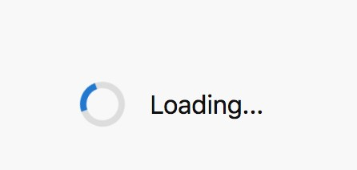

1. **Remove** the **delay** in **ProjectService** before continuing to the next lab.

### You have completed Lab 25

Lab 26: Router Navigation

## Objectives

 Create a Home module, component and route  Add a navigation menu

## Steps

### Create a Home module, component and route

1. If you don’t already have one open, **open** a **command prompt.** Set the directory to **project-manage**.
2. **Run** the following **command** to **generate** a new feature module for components and other Angular constructs related to the **home** page.

|  |
| --- |
| ng g module home --routing --module=app |

If you open src\app\app.module.ts you will notice the HomeModule was automatically added to the imports of the AppModule.

1. Run the command to generate a home container component inside the home feature module you created in the last step.

|  |
| --- |
| ng g component home/home-container |

1. Edit the component’s template as follows.

|  |
| --- |
| src\app\home\home-container\home-container.component.html |
| ~~<p>~~  ~~home-container works!~~  ~~</p>~~  <h1>Home </h1> |

1. Add a route that displays the component.

|  |
| --- |
| src\app\home\home-routing.module.ts |
| ...  const routes: Routes = [  { path: 'home', component: HomeContainerComponent },  ];  ... |

If you have **Angular Snippets** available in your editor you can type part of **a-route-path-eager**, press **enter**, and the snippet will unfold.

To learn more visit the documentation on Angular Snippets.

1. Make the home route the default route in the application.

|  |
| --- |
| src\app\app-routing.module.ts |
| ...  const routes: Routes = [  { path: '', pathMatch: 'full', redirectTo: 'home' }  ];  ... |

Use the **a-route-path-default** snippet.

1. Make the following changes so the router knows where to output the component when it renders.

|  |
| --- |
| src\app\app.component.html |
| ~~<app-projects-container> </app-projects-container>~~  <div *class*="container">  <router-outlet> </router-outlet>  </div> |

1. **Save** your changes and **navigate** to http://localhost:4200/ in your browser.
2. The browser should be redirected to http://localhost:4200/home and see the **HomeContainerComponent**.

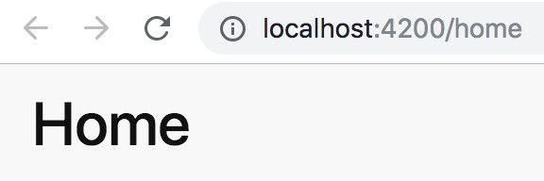

### Configure a Route

1. Open the **projects-routing.module.ts** file and add a route to the

#### ProjectsContainerComponent.

|  |
| --- |
| src\app\projects\projects-routing.module.ts |
| import { NgModule } from '@angular/core';  import { Routes, RouterModule } from '@angular/router';  import { ProjectsContainerComponent } from './projects-container/ projects-container.component';  const routes: Routes = [  { path: 'projects', component: ProjectsContainerComponent }  ];  @NgModule({  imports: [RouterModule.forChild(routes)], exports: [RouterModule]  })  export class ProjectsRoutingModule {} |

Use the **a-route-path-eager** snippet.

### Add a navigation menu

1. **Add** a **navigation menu** to your application.

|  |
| --- |
| src\app\app.component.html |
| <header *class*="sticky">  <a *href*="#" *class*="logo">  <img *src*=" ../assets/logo-3.svg" *alt*="logo" *width*="49" *height*="99">  </a>  <a *[routerLink]*="['./home']" *class*="button rounded"  *routerLinkActive*="active">  <span *class*="icon-home"> </span> Home  </a>  <a *[routerLink]*="['./projects']" *class*="button rounded"  *routerLinkActive*="active"> Projects  </a>  </header>  <div *class*="container">  <router-outlet>  </router-outlet>  </div> |
| snippets\lab26-step09.html |

1. **Add** the following **styles** for the **navigation** menu.

|  |
| --- |
| src\styles.css |
| ...  header {  height: 5.1875rem;  }  a*.button.active* {  border: 1px solid var( --fore-color);  } |
| snippets\lab26-step10.css |

1. **Verify** the menu is working by following these steps:
   1. **Save** your changes.
   2. The browser will automatically **reload**.
   3. You should see the **navigation** menu.

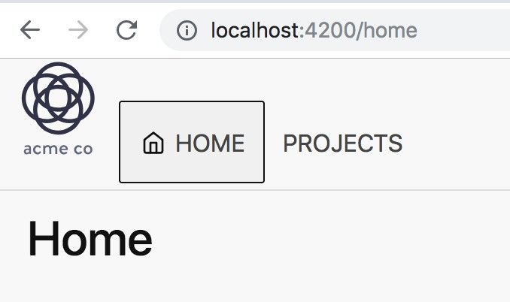

* 1. **Click** on **Projects** and you should navigate to the project list.

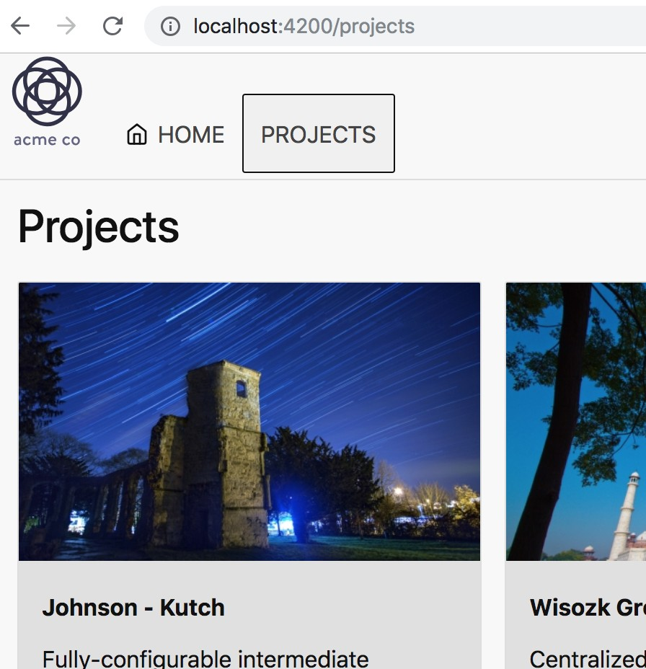

* 1. **Click** on **Home** and you should navigate back to home.

### You have completed Lab 26

Lab 27: Route Parameters

## Objectives

 Navigate to a route with a parameter

## Steps

### Navigate to a route with a parameter

1. **Add** a **find method** to ProjectService to return a Project by Id.

|  |
| --- |
| src\app\projects\shared\project.service.ts |
| ...  export class ProjectService {  private projectsUrl = environment.backendUrl + '/projects/'; constructor(private http: HttpClient) {}  find(id: number): Observable<Project> {  const url = this.projectsUrl + id;  return this.http.get<Project>(url).pipe(  catchError((error: HttpErrorResponse) => {  console.error(error);  return throwError('An error occurred loading the project');  })  );  }  …  } |
| snippets\lab27-step01.txt |

1. **Copy** the two directories:

#### snippets\Lab25-RouteParameters\project-detail

#### snippets\Lab25-RouteParameters\project-detail-container

*Into* the \**code\labs\working\project-manage\src\app\projects** directory (be sure to merge the new files into the existing files).

These directories contain some pre-built components will use in this lab.

Take a moment to **review the code.**

1. **Add** the two new **components** to the **declarations** in the **ProjectsModule**.

|  |
| --- |
| src\app\projects\projects.module.ts |
| import { ProjectDetailComponent } from './project-detail/project- detail.component';  import { ProjectDetailContainerComponent } from './project-detail- container/project-detail-container.component';  @NgModule({ imports: [ ...], declarations: [  ...,  ProjectDetailComponent,  ProjectDetailContainerComponent  ]  })  export class ProjectsModule {} |

1. **Add** a **route** to display the **ProjectDetailContainer** component you just added.

...

const routes: Routes = [

{ path: 'projects', component: ProjectsContainerComponent },

];

...

src\app\projects\projects-routing.module.ts

{ path: 'projects/:id', component: ProjectDetailContainerComponent }

1. Make the card clickable by surrounding it with a link.

|  |
| --- |
| src\app\projects\project-card\project.card.component.html |
| <a *[routerLink]*="['./', project.id]">  <div *class*="card">  <img *[src]*=" project.imageUrl" *[alt]*="project.name">  <section *class*="section dark">  <h5 *class*="strong">  <strong>{{project.name}} </strong>  </h5>  <p>{{project.description}} </p>  <p>  Budget :  {{project.budget | currency : 'USD': 'symbol': '0.0-2'}}  </p>  <button *class*=" bordered" *(click)*="onEditClick(project, $event)">  <span *class*="icon-edit "> </span> Edit  </button>  </section>  </div>  </a> |

1. Verify the code works by following these steps:
2. Save your changes.
3. Click on Projects in the navigation if you aren’t already at the projects route.
4. Click on any of the project cards.
5. You should see the projects detail page for the project you clicked.

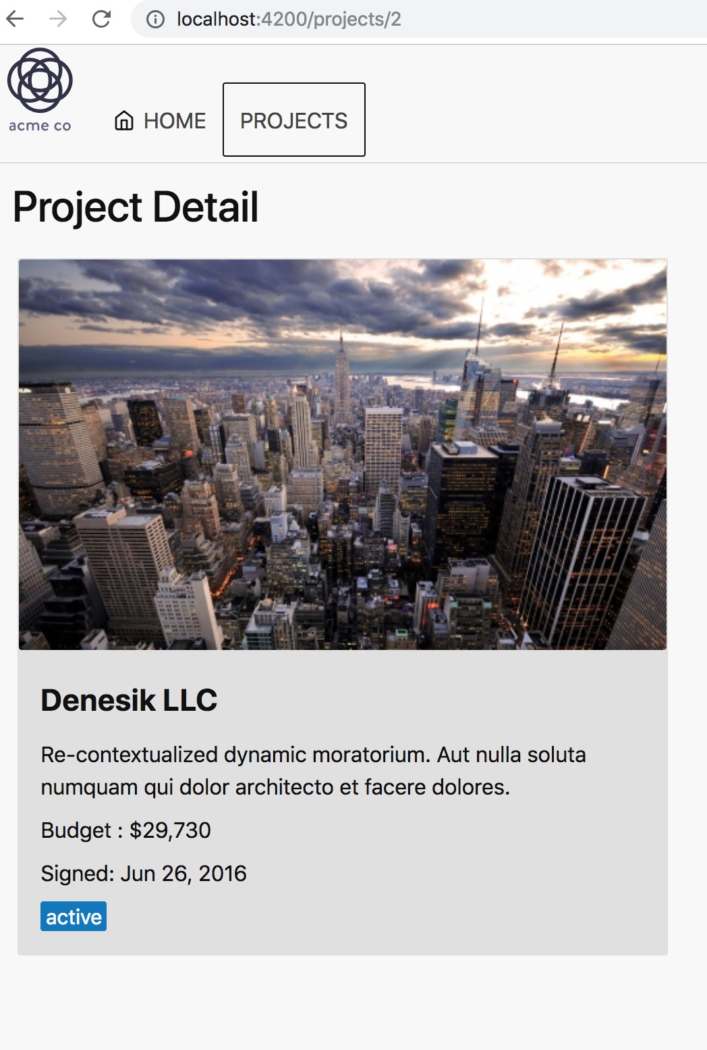

1. Click the back button in your browser to see the list of projects again.
2. Click a different project card.
3. You should see the projects detail page for the project you clicked.

Now that you have it working, take some time to review the code and step through it to see how all the pieces connect to provide a list to detail view.

### You have completed Lab 27

Lab 28: Custom Pipe

## Objectives

 Create a custom pipe

 Format data using a custom pipe

## Steps

### Create a custom pipe

1. If you don’t already have one open, **open** a **command prompt.** Set the directory to **project-manage**.
2. **Run** the following **command** to **generate** a new shared feature module for pipes, components and directives used across the application in several different feature modules.

|  |
| --- |
| ng g module shared |

1. Run the follow command to generate a custom pipe.

|  |
| --- |
| ng g pipe shared/truncate-string --export |

Adding the **shared/** path before the pipe name will create the pipe in the shared folder and add it to the **declarations** of the shared module you created in the previous step. The flag **--export** tells the Angular CLI to also add the pipe to the exports of the shared module so it can be used in other feature modules if the SharedModule is imported. declaring.

1. **Implement** the **transform** method in the custom pipe.

|  |
| --- |
| src\app\shared\truncate-string.pipe.ts |
| import { Pipe, PipeTransform } from '@angular/core';  @Pipe({  name: 'truncateString'  })  export class TruncateStringPipe implements PipeTransform {  transform(value: any, length: number): any {  if (value.length > length) {  return value.substring(0, +length) + ' ...';  } else {  return value;  }  } |
| snippets\lab28-step04.txt |

### Format data using a custom pipe

1. **Import** the **SharedModule into** the feature module **ProjectModule** so it can be used in the **project-card.component.html** template.

|  |
| --- |
| src\app\shared\truncate-string.pipe.ts |
| ...  @NgModule({ imports: [  CommonModule, ProjectsRoutingModule, ReactiveFormsModule, SharedModule  ],  declarations: [  ... ]  })  export class ProjectsModule {} |

1. Use the pipe in a the template for a component.

|  |
| --- |
| src\app\projects\project-card\project-card.component.html |
| ...  <h5 *class*=“strong">  <strong>{{project.name}} </strong>  </h5>  <p>{{project.description | truncateString: 60}} </p>  ... |

1. Verify the code is working.
   1. Save your code changes.
   2. Click on Projects in the navigation if you aren’t at that route already.
   3. The project descriptions should all be truncated at 60 characters and all end with an ellipsis ( **. . .**) as shown below.

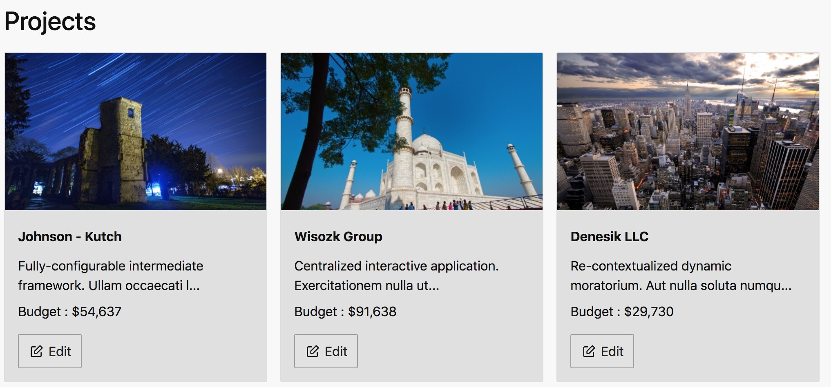

### You have completed Lab 28

Lab 29: Build & Deploy

## Objectives

 Build an Angular application

 Deploy the application to a web server

## Steps

### Build an Angular application

1. If you don’t already have one open, **open** a **command prompt.** Set the directory to **project-manage**.
2. **Run** the following **command** to **build** the application for production deployment.

|  |
| --- |
| ng build --prod |

1. When the command completes you should see output similar but not exactly as shown below.

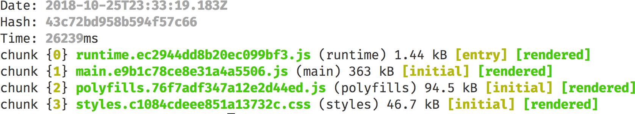

A **dist\project-manage** directory is created **inside your top level project-manage directory** with the files needed for deployment.

4.

1. **Run** the following **command** to change your current directory.

|  |
| --- |
| cd dist\project-manage |

### Deploy the application to a web server

1. **Run** the following **command** to install a Node.js web server named **serve**.

|  |
| --- |
| npm install serve -g |

Assuming you would like to serve a static site, single page application or just a static file (no matter if on your device or on the local network), this package is a development web server that serves static content.

It behaves exactly like static deployments on https://zeit.co/now

so it's perfect for developing your static project.

For more information see: https[://ww](http://www.npmjs.com/package/serve)w[.np](http://www.npmjs.com/package/serve)mj[s.com/package/serve](http://www.npmjs.com/package/serve)

1. **Run** the following **command** to serve your current directory **dist\project- manage.**

|  |
| --- |
| serve |

1. The output should be as follows.

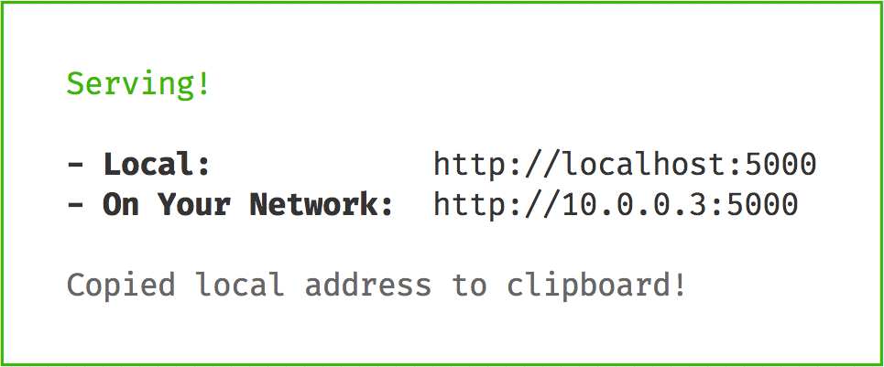

1. **Open** a browser and paste the local link copied to your clipboard in the last step into the address bar.
2. You should see the **application running** in your browser.
3. **Click** on **projects** in the top navigation.
4. After navigating to the projects route, **refresh** your **browser**.
5. You should see a **404 error** page.

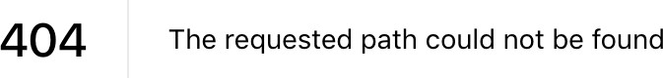

1. Use **Ctrl+C** to **stop** the web server.
2. **Run** the **serve** command again but add the **-s** flag for *single-page applications.*

|  |
| --- |
| serve -s |

1. Follow these steps to verify the server is now redirecting to index.html when it can’t find a route.
   1. You should see the **application running** in your browser.
   2. **Click** on **projects** in the top navigation.
   3. After navigating to the projects route, **refresh** your **browser**.
   4. You should see the **projects page refresh** and **display the projects**. Note that you are **no longer getting a 404** error.

### You have completed Lab 29

If time permits you can follow very similar steps to deploy the application on common production web servers including Apache and IIS by following the specific directions in the Angular documentation.

https://angular.io/guide/deployment#production-servers

The **snippets** directory contains a **web.config for IIS** and an **.htaccess file for Apache** to make it easier.

Appendix A: How to Skip Labs

## Labs can be skipped by attendees who:

 arrive late, leave early

 get pulled into a meeting

 have a doctors appointment

 understand a topic and want to move on to a topic they don't know  etc...

## Steps

1. Close any editor(s) and command prompt or terminal related to the course labs.
2. **Open** a **command prompt.** Set the directory to the **begin\project-manage** for the lab on which you would like to start working on.
3. Run the command.

|  |
| --- |
| npm install |

1. Run the command.

|  |
| --- |
| ng serve --disable-host-check |

1. If you are working a lab which requires the backend api (lab 21 or later). Open another command-line or terminal. Run the command.

|  |
| --- |
| npm run api |

For a specific example see the next page.

For example, if you want to:

* Finish | Lab 24: Http Put
* Skip | Lab 25: Showing a Loading Indicator
* Work on | Lab 26: Router Navigation

...then

* Close the project-manage folder where you were working on Lab 24: Http Put
* Open the directory below in your editor and on the command-line:
  + code\labs\lab26\begin\project-manage
* Run an npm install and after it finishes
* Run the commands
  + ng serve --disable-host-check
  + ng run api
    - In separate command-line or terminal windows Note that you:
* Won't lose your current code
* Will work on future labs in the directory:
  + code\labs\lab26\begin\project-manage